A324-EUR-Vinca-Neolithic-Ceramic-Male Anthropomorphic Figurine, 5500-4500 BCE

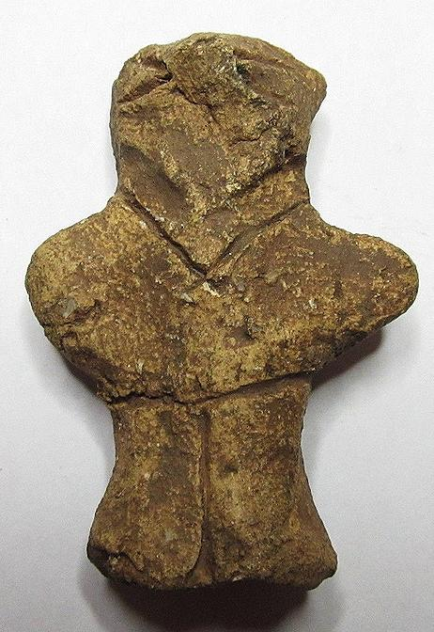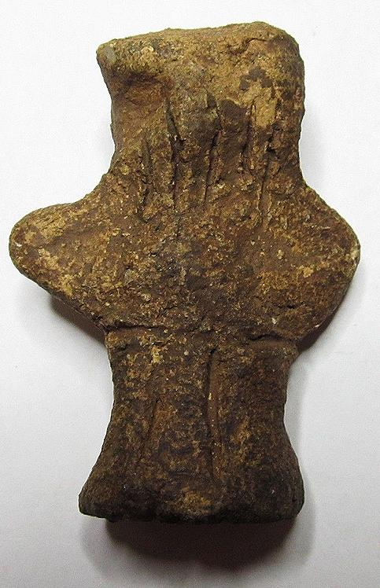 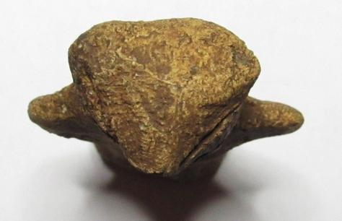

Figs. 1-3. Vinča-Neolithic-Ceramic-Male Anthropomorphic Figurine, 5500-4500 BCE

Case no.: 3

Accession Number: A324

Formal Label: Vinča-Neolithic-Ceramic-Male Anthropomorphic Figurine, 5500-4500 BCE

**Display Description:**

The Vinča culture was named for its type site, Vinča-Belo Brdo tell or mound, on the right bank of the Danube River in Belgrade, Serbia.

Early phase anthropomorphic figurines from this site have triangular heads, flat bodies with short outstretched arms and closed legs. The treatment of facial and body features was done by simple incisions into the clay without modeling. Later phase anthropomorphic figurines are more polygonal, with more pronounced facial features, such as modeled noses and distinctive half-moon eyes and modeled arms. For both periods no indication of a mouth is present. Some theorize that these figurines are deities for ritual practice, while others see them as ancestral cult objects.

The present figurine is from the early phase and has a schematized anatomical shape -- a flat body, triangular head, short, outstretched arms and closed legs, a lack of distinctive facial features, a “V”–shaped wedge for a head, a ridge for a chin, no mouth to speak, and squinty eyes (suggesting too much sun while planting crops to survive) and dressed in a “V” neck blouse and non-descript trousers but no shoes. All these attributes suggest that this is an anthropomorphic individual (perhaps an ancestral figure) and not a deity.

**LC Classification:** GN776.2.V5

Date or Time Horizon: Middle Neolithic/Copper Age-5500 cal BCE

Geographical Area: SE Europe

**Map, GPS coordinates:** 44°45′43″N 20°37′23″E (Vinča Belo-Brdo, Serbia)

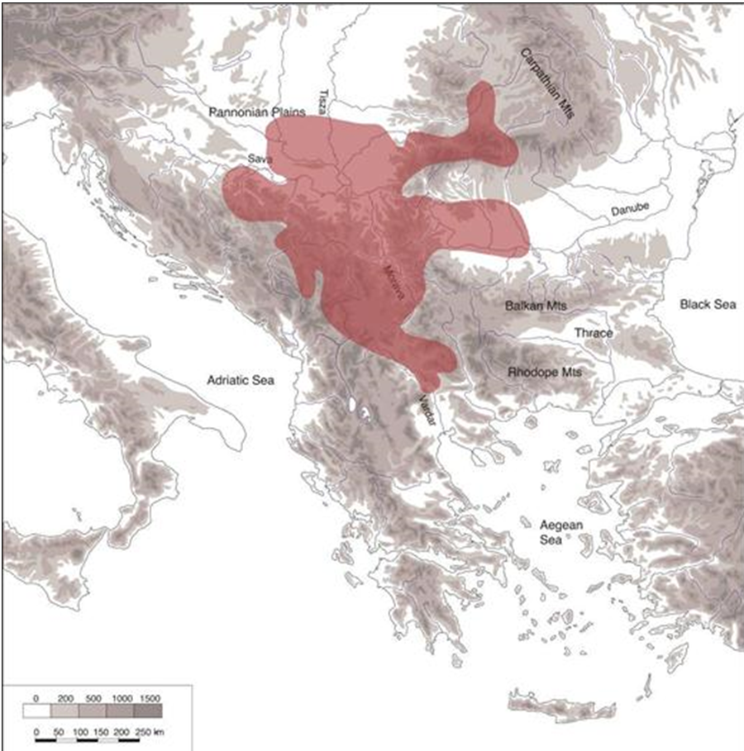



Fig. 4. Map of the extent of Vinča culture. Adapted after Kaiser and Voytek (1983: 333, fig. 1) and Chapman (1981); from https://www.ucl.ac.uk/silva/rise-metallurgy-eurasia/images/5.1.jpg?hires

Fig. 5. Map of the Central Balkans. Beograd = Belgrade, Serbia, and the approximate location of the Vinča Belo-Brdo site. From http://drakenberg.weebly.com/uploads/6/7/4/7/6747442/9582880.jpg?578

Cultural Affiliation: Vinča Culture

Medium: Clay

Dimensions: H 48.03 mm; 1.89 in

Weight: 17 gm; .5 oz

Condition: original

Provenance: unknown

**Discussion:**

The Vinča culture emerged at the inception of the Middle Neolithic/Copper or Chacolithic Age (5500-4500 BCE) with origins that are debated as either having derived from the earlier Starčevo culture (6200-4500 BCE) of the area, which has been reputed to have been the source of a Proto Indo-European language (PIE), or from migrations from a PIE homeland of a Kurgan or mound-building culture in the Pontic steppe north of the Black Sea (The Kurgan Hypothesis).

Vinča settlers initiated a cultural uniformity that they expressed in farming, making dark pottery fired under reducing conditions comprising zoomorphic and anthropomorphic figurines and making clay tablets with so-called Vinča symbols, which have the appearance of proto-writing (Winn Luca 2008: 26). The type site of the Vinča-Belo Brdo comprised 7 m of Vinča cultural debris overlying 2 m of the previous Starčevo culture. Elsewhere in Serbia and the western part of Romania large Vinča tell villages ranged up to 100 ha in size.

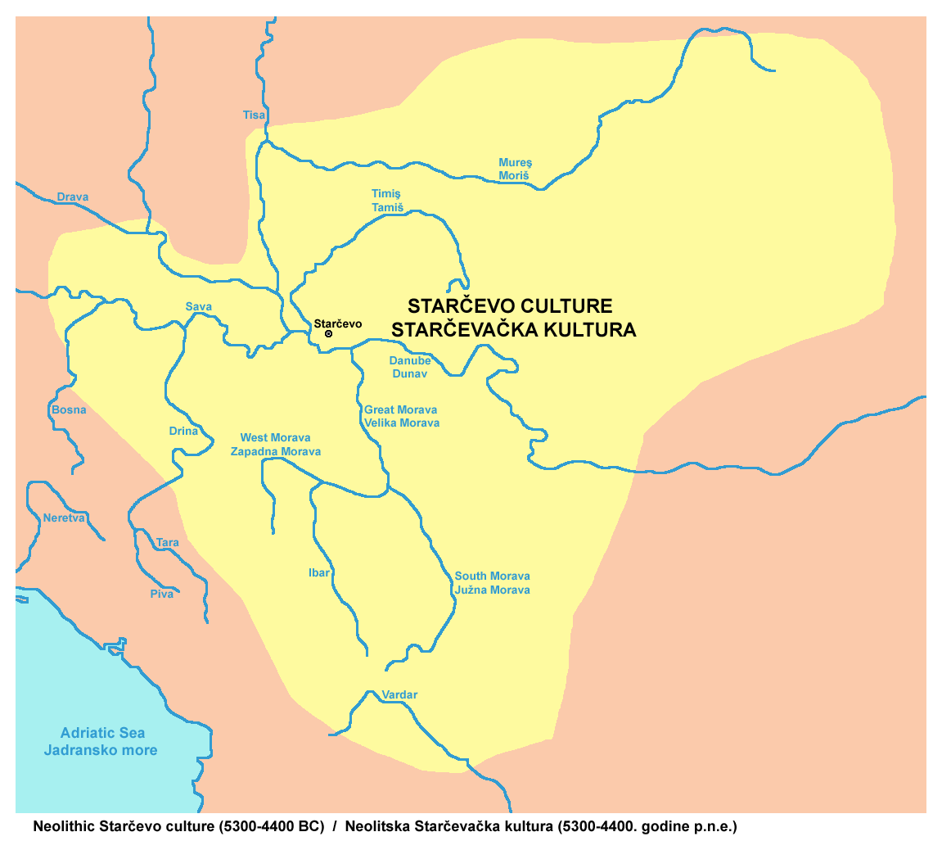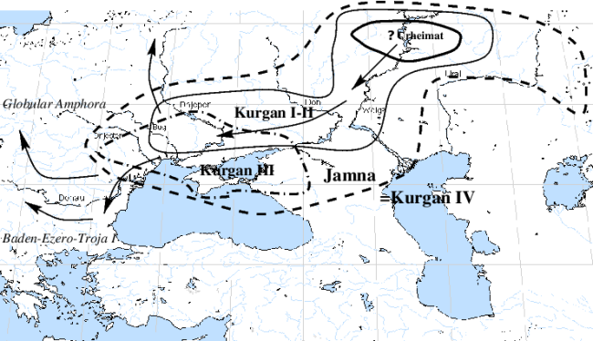

Fig. 6. The extent of the Starčevo culture (6200-4500 BCE) in southeast Europe. After https://upload.wikimedia.org/wikipedia/commons/thumb/e/ea/Starcevo_culture.png/450px-Starcevo_culture.png

Fig. 7. Overview of [Marija Gimbutas](https://commons.wikimedia.org/w/index.php?title=Marija_Gimbutas&action=edit&redlink=1)' [Kurgan](https://commons.wikimedia.org/w/index.php?title=Kurgan&action=edit&redlink=1) hypothesis showing the PIE migrations from the Pontic Steppes into southeastern Europe. Made by [en:User:Dbachmann](https://en.wikipedia.org/wiki/User:Dbachmann) and originally at [en:Image:Kurgan map.png](https://en.wikipedia.org/wiki/Image:Kurgan_map.png).

**References:**

Biagi, P. Gratuze, B. and Boucetta, S. 2007. “New data on the archaeological obsidians from Banat and Transylvania (Romania).” In M. Spataro and P. Biagi (eds.) *A short walk through the Balkans: The first farmers of the Carpathian basin and Adjacent regions*. Quaderno 12. Trieste: Societa per la preistoria e protoistoria della regione Friuli-Venezia Giulia, pp. 129-39.

Chapman, J. 1981. *The Vinča Culture of South East Europe. Studies in chronology, economy and society*. British Archaeological Reports, International Series 117, Oxford: Archeopress. 2v.

Gimbutas, Marija. 1970. “Proto-Indo-European Culture: The Kurgan Culture during the Fifth, Fourth, and Third Millennia B.C.” In Cardona, George; Hoenigswald, Henry M.; Senn, Alfred, Indo-European and Indo-Europeans: Papers Presented at the Third Indo-European Conference at the University of Pennsylvania. Philadelphia: University of Pennsylvania Press, pp. 155–197.

Haak, Wolfgang *et al*. 2015. “Massive migration from the steppe is a source for Indo-European languages in Europe.” bioRxiv preprint first posted online Feb. 10, 2015; doi: http://dx.doi.org/10.1101/013433 Now published in *Nature* doi: [10.1038/nature14317](http://dx.doi.org/10.1038/nature14317)

Holmberg, E.J. 1964. “The Appearance of Neolithic Black Burnished Ware in Mainland Greece,” *American Journal of Archaeology* 68(4): 343-8.

Kaiser, T. and B. Voytek. 1983. “Sedentism and economic change in the Balkan Neolithic,” *Journal of Anthropological Archaeology* 2(4): 323-353.

Luca, S. A. 2008. “The Neolithic and Eneolithic periods in Transylvania.” In Institute of Archaeomythology and Muzeul Brukenthal, *The Danube script: Neo-eneolithic writing in southeastern Europe* [exhibition catalogue]. Sebastopol, California, Institute of Archaeomythology, pp. 23-38,

Özdoğan, M. 2003. “The Prehistory of Northwestern Turkey - The synoptic overview of the latest evidence.” In D.V. Grammenos (ed.) *Recent Research in the Prehistory of the Balkans*. Thessaloniki: Archaeological Institute of Northern Greece and the Archaeological Receipts Fund, pp. 329- 68.

Thissen, L. (2001) “Time trajectories for the Neolithic of Central Anatolia, CANeW project,” http://www.canew.org/files/Thissen%20lecture.pdf, [23.11.2001]: 1-26.

─── (2007) “CANeW Central Anatolia and Cilicia 14C Chart, CANeW project,” http://www.canew.org/cachronobox.html, updated at 16.03.2007.

Vasic, Mīloje M. 1932-1936. *Preistoriska Vinča*. Beograd [Belgrade]: Državne Štamparije. 4 v.

Winn, Milton MacChesney. 1981. [*Pre-writing in Southeastern Europe: the sign system of the Vinča culture ca. 4000 B.C.*](http://www.worldcat.org/title/pre-writing-in-southeastern-europe-the-sgin-system-of-the-vinca-culture-ca-4000-bc/oclc/781534609&referer=brief_results) Calgary, Alberta: Western Publishers.

|  |  |
| --- | --- |
|  |  |

A331-EUR-Vinca-Neolithic-Ceramic-Female Anthropomorphic Figurine, 5500-4500 BCE

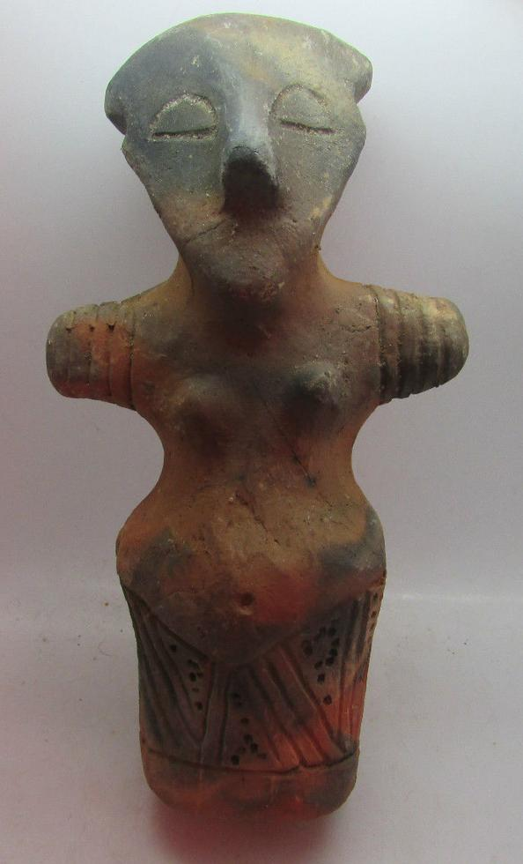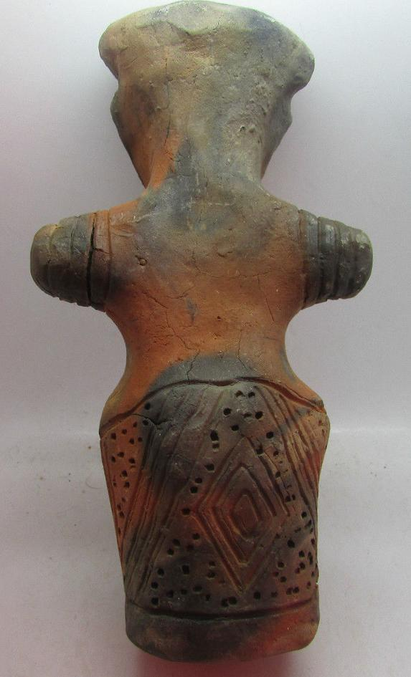 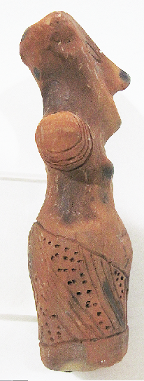

Figs. 1-3. Vinča-Neolithic-Ceramic-Female Anthropomorphic Figurine, 5500-4500 BCE

Formal Label: Vinča-Neolithic-Ceramic-Female Anthropomorphic Figurine, 5500-4500 BCE

Case no.: 3

Accession Number: A331

Formal Label: Vinča-Neolithic-Ceramic-Female Anthropomorphic Figurine, 5500-4500 BCE

**Display Description:**

The Vinča culture was named for its type site, Vinča-Belo Brdo tell or mound, on the right bank of the Danube River in Belgrade, Serbia.

Early phase anthropomorphic figurines from this site have triangular heads, flat bodies with short outstretched arms and closed legs. The treatment of facial and body features was done by simple incisions into the clay without modeling. Later phase anthropomorphic figurines are more polygonal, with more pronounced facial features, such as modeled noses and distinctive half-moon eyes and modeled arms. For both periods no indication of a mouth is present. Some theorize that these figurines are deities for ritual practice, while others see them as ancestral cult objects.

This female figurine is of the later period and has modeled breasts and a modeled nose. It wears a skirt with three interlocking triangular motifs (two with punctates as a design bordering on one with diagonal incisions) on the front and a large incised diamond design within punctates on the rear. These designs are probably to mimic a cloth pattern. It does not wear any covering above the skirt. This figurine wears a modeled cap and has four bracelets on each arm. Its arms are stretched outward. Its eyes are closed.

**LC Classification:** GN776.2.V5

Date or Time Horizon: Middle Neolithic/Copper Age-5500-4500 BCE

Geographical Area: SE Europe

**Map, GPS coordinates:** 44°45′43″N 20°37′23″E (Vinča Belo-Brdo, Serbia)





Fig. 4. Map of the extent of Vinča culture. Adapted after Kaiser and Voytek (1983: 333, fig. 1) and Chapman (1981); from https://www.ucl.ac.uk/silva/rise-metallurgy-eurasia/images/5.1.jpg?hires

Fig. 5. Map of the Central Balkans. Beograd = Belgrade, Serbia, and the approximate location of the Vinča Belo-Brdo site. From http://drakenberg.weebly.com/uploads/6/7/4/7/6747442/9582880.jpg?578

Cultural Affiliation: Vinča Culture

Medium: Clay

Dimensions: H 143.40 mm, 5.65 in

Weight: 309 gm, 10 7/8 oz

Provenance: Ex: Michael Davies 2 Hanover Court Didcot Oxfordshire ox11 8nu United Kingdom

**Discussion:**

The Vinča culture emerged at the inception of the Middle Neolithic/Copper or Chacolithic Age (5500-4500 BCE) with origins that are debated as either having derived from the earlier Starčevo culture (6200-4500 BCE) of the area, which has been reputed to have been the source of a Proto Indo-European language (PIE), or from migrations from a PIE homeland of a Kurgan or mound-building culture in the Pontic steppe north of the Black Sea (The Kurgan Hypothesis).

Vinča settlers initiated a cultural uniformity that they expressed in farming, making dark pottery fired under reducing conditions comprising zoomorphic and anthropomorphic figurines and making clay tablets with so-called Vinča symbols, which have the appearance of proto-writing (Winn Luca 2008: 26). The type site of the Vinča-Belo Brdo comprised 7 m of Vinča cultural debris overlying 2 m of the previous Starčevo culture. Elsewhere in Serbia and the western part of Romania large Vinča tell villages ranged up to 100 ha in size.



Fig. 6. The extent of the Starčevo culture (6200-4500 BCE) in southeast Europe. After https://upload.wikimedia.org/wikipedia/commons/thumb/e/ea/Starcevo_culture.png/450px-Starcevo_culture.png

Fig. 7. Overview of [Marija Gimbutas](https://commons.wikimedia.org/w/index.php?title=Marija_Gimbutas&action=edit&redlink=1)' [Kurgan](https://commons.wikimedia.org/w/index.php?title=Kurgan&action=edit&redlink=1) hypothesis showing the PIE migrations from the Pontic Steppes into southeastern Europe. Made by [en:User:Dbachmann](https://en.wikipedia.org/wiki/User:Dbachmann) and originally at [en:Image:Kurgan map.png](https://en.wikipedia.org/wiki/Image:Kurgan_map.png).

**References:**

Biagi, P. Gratuze, B. and Boucetta, S. 2007. “New data on the archaeological obsidians from Banat and Transylvania (Romania).” In M. Spataro and P. Biagi (eds.) *A short walk through the Balkans: The first farmers of the Carpathian basin and Adjacent regions*. Quaderno 12. Trieste: Societa per la preistoria e protoistoria della regione Friuli-Venezia Giulia, pp. 129-39.

Chapman, J. 1981. *The Vinča Culture of South East Europe. Studies in chronology, economy and society*. British Archaeological Reports, International Series 117, Oxford: Archeopress. 2v.

Gimbutas, Marija. 1970. “Proto-Indo-European Culture: The Kurgan Culture during the Fifth, Fourth, and Third Millennia B.C.” In Cardona, George; Hoenigswald, Henry M.; Senn, Alfred, Indo-European and Indo-Europeans: Papers Presented at the Third Indo-European Conference at the University of Pennsylvania. Philadelphia: University of Pennsylvania Press, pp. 155–197.

Haak, Wolfgang *et al*. 2015. “Massive migration from the steppe is a source for Indo-European languages in Europe.” bioRxiv preprint first posted online Feb. 10, 2015; doi: http://dx.doi.org/10.1101/013433 Now published in *Nature* doi: [10.1038/nature14317](http://dx.doi.org/10.1038/nature14317)

Holmberg, E.J. 1964. “The Appearance of Neolithic Black Burnished Ware in Mainland Greece,” *American Journal of Archaeology* 68(4): 343-8.

Kaiser, T. and B. Voytek. 1983. “Sedentism and economic change in the Balkan Neolithic,” *Journal of Anthropological Archaeology* 2(4): 323-353.

Luca, S. A. 2008. “The Neolithic and Eneolithic periods in Transylvania.” In Institute of Archaeomythology and Muzeul Brukenthal, *The Danube script: Neo-eneolithic writing in southeastern Europe* [exhibition catalogue]. Sebastopol, California, Institute of Archaeomythology, pp. 23-38,

Özdoğan, M. 2003. “The Prehistory of Northwestern Turkey - The synoptic overview of the latest evidence.” In D.V. Grammenos (ed.) *Recent Research in the Prehistory of the Balkans*. Thessaloniki.: Archaeological Institute of Northern Greece and the Archaeological Receipts Fund, pp. 329- 68,

Thissen, L. (2001) “Time trajectories for the Neolithic of Central Anatolia, CANeW project,” http://www.canew.org/files/Thissen%20lecture.pdf, [23.11.2001]: 1-26.

─── (2007) “CANeW Central Anatolia and Cilicia 14C Chart, CANeW project,” http://www.canew.org/cachronobox.html, updated at 16.03.2007.

Vasic, Mīloje M. 1932-1936. *Preistoriska Vinča*. Beograd [Belgrade]: Državne Štamparije. 4 v.

Winn, Milton MacChesney. 1981. [*Pre-writing in Southeastern Europe : the sign system of the Vinča culture ca. 4000 B.C.*](http://www.worldcat.org/title/pre-writing-in-southeastern-europe-the-sgin-system-of-the-vinca-culture-ca-4000-bc/oclc/781534609&referer=brief_results) Calgary, Alberta: Western Publishers.

A318-EUR-Vinca-Neolithic-Ceramic-Female Anthropomorphic Figurine, 5500-4500 BCE

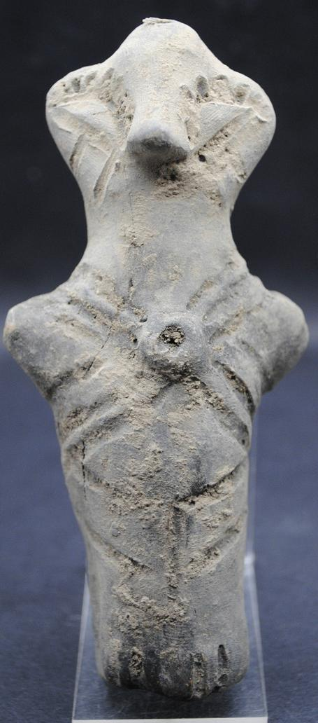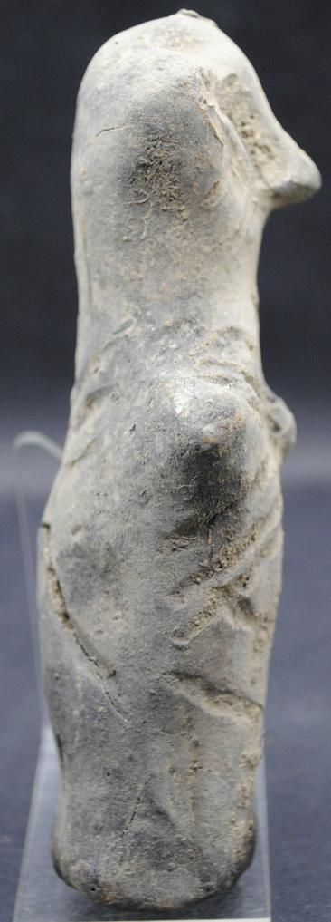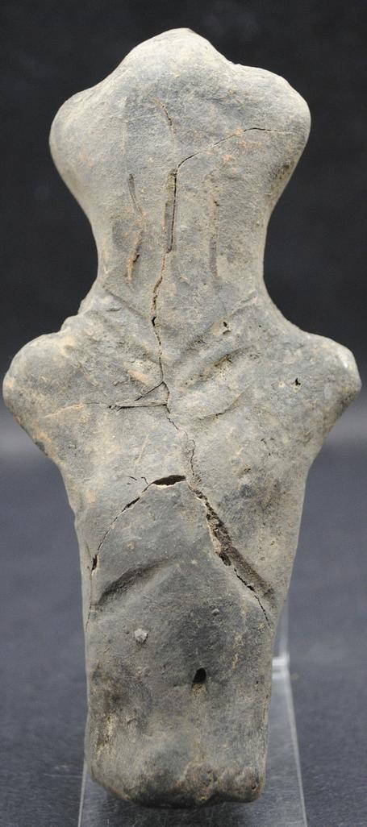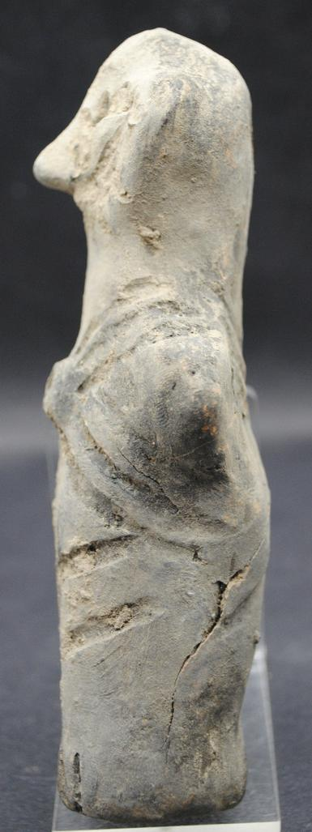

Figs. 1-4. Vinča-Neolithic-Ceramic-Female Anthropomorphic Figurine, 5500-4500 BCE

Case no.: 3

Accession Number: A318

Formal Label: Vinča-Neolithic-Ceramic-Female Anthropomorphic Figurine, 5500-4500 BCE

**Display Description:**

The Vinča culture was named for its type site, Vinča-Belo Brdo tell or mound, on the right bank of the Danube River in Belgrade, Serbia.

Early phase anthropomorphic figurines from this site have triangular heads, flat bodies with short outstretched arms and closed legs. The treatment of facial and body features was done by simple incisions into the clay without modeling. Later phase anthropomorphic figurines are more polygonal, with more pronounced facial features, such as modeled noses and distinctive half-moon eyes and modeled arms. For both periods no indication of a mouth is present. Some theorize that these figurines are deities for ritual practice, while others see them as ancestral cult objects.

This Vinča ceramic anthropomorphic figurine is from the later period. It has a pronounced nose, and two slanting, parallel facial tattoos beneath slanted half-moon eyes. Although it has no discernible breasts, it has pronounced incisions for eyelashes, it wears long hair in the back and its lower body is covered by a flounced kulotte. Therefore it is possible that this is a female. It has a circular gorget that is fastened by straps over and under the shoulders. It wears no shoes.

**LC Classification:** GN776.2.V5

Date or Time Horizon: Middle Neolithic/Copper Age-5500-4500 BCE

Geographical Area: SE Europe

**Map, GPS coordinates:** 44°45′43″N 20°37′23″E (Vinča Belo-Brdo, Serbia)





Fig. 5. Map of the extent of Vinča culture. Adapted after Kaiser and Voytek (1983: 333, fig. 1) and Chapman (1981); from https://www.ucl.ac.uk/silva/rise-metallurgy-eurasia/images/5.1.jpg?hires

Fig. 6. Map of the Central Balkans. Beograd = Belgrade, Serbia, and the approximate location of the Vinča Belo-Brdo site. From http://drakenberg.weebly.com/uploads/6/7/4/7/6747442/9582880.jpg?578

Cultural Affiliation: Vinča Culture

Medium: Clay

Dimensions: H 132.70 mm, 5.22 in

Weight: 186 gm, 6.5 oz

Provenance: Ex: Ancient-Artefacts-UK 11 Wessex Road, Didcot, Oxfordshire, ox11 8bu, United Kingdom.

**Condition:** Original. Some cracks but no repairs.

**Discussion:**

The Vinča culture emerged at the inception of the Middle Neolithic/Copper or Chacolithic Age (5500-4500 BCE) with origins that are debated as either having derived from the earlier Starčevo culture (6200-4500 BCE) of the area, which has been reputed to have been the source of a Proto Indo-European language (PIE), or from migrations from a PIE homeland of a Kurgan or mound-building culture in the Pontic steppe north of the Black Sea (The Kurgan Hypothesis).

Vinča settlers initiated a cultural uniformity that they expressed in farming, making dark pottery fired under reducing conditions comprising zoomorphic and anthropomorphic figurines and making clay tablets with so-called Vinča symbols, which have the appearance of proto-writing (Winn Luca 2008: 26). The type site of the Vinča-Belo Brdo comprised 7 m of Vinča cultural debris overlying 2 m of the previous Starčevo culture. Elsewhere in Serbia and the western part of Romania large Vinča tell villages ranged up to 100 ha in size.



Fig. 7. The extent of the Starčevo culture (6200-4500 BCE) in southeast Europe. After https://upload.wikimedia.org/wikipedia/commons/thumb/e/ea/Starcevo_culture.png/450px-Starcevo_culture.png

Fig. 8. Overview of [Marija Gimbutas](https://commons.wikimedia.org/w/index.php?title=Marija_Gimbutas&action=edit&redlink=1)' [Kurgan](https://commons.wikimedia.org/w/index.php?title=Kurgan&action=edit&redlink=1) hypothesis showing the PIE migrations from the Pontic Steppes into southeastern Europe. Made by [en:User:Dbachmann](https://en.wikipedia.org/wiki/User:Dbachmann) and originally at [en:Image:Kurgan map.png](https://en.wikipedia.org/wiki/Image:Kurgan_map.png).

**References:**

Biagi, P. Gratuze, B. and Boucetta, S. 2007. “New data on the archaeological obsidians from Banat and Transylvania (Romania).” In M. Spataro and P. Biagi (eds.) *A short walk through the Balkans: The first farmers of the Carpathian basin and Adjacent regions*. Quaderno 12. Trieste: Societa per la preistoria e protoistoria della regione Friuli-Venezia Giulia, pp. 129-39.

Chapman, J. 1981. *The Vinča Culture of South East Europe. Studies in chronology, economy and society*. British Archaeological Reports, International Series 117, Oxford: Archeopress. 2v.

Gimbutas, Marija. 1970. “Proto-Indo-European Culture: The Kurgan Culture during the Fifth, Fourth, and Third Millennia B.C.” In Cardona, George; Hoenigswald, Henry M.; Senn, Alfred, Indo-European and Indo-Europeans: Papers Presented at the Third Indo-European Conference at the University of Pennsylvania. Philadelphia: University of Pennsylvania Press, pp. 155–197.

Haak, Wolfgang *et al*. 2015. “Massive migration from the steppe is a source for Indo-European languages in Europe.” bioRxiv preprint first posted online Feb. 10, 2015; doi: http://dx.doi.org/10.1101/013433 Now published in *Nature* doi: [10.1038/nature14317](http://dx.doi.org/10.1038/nature14317)

Holmberg, E.J. 1964. “The Appearance of Neolithic Black Burnished Ware in Mainland Greece,” *American Journal of Archaeology* 68(4): 343-8.

Kaiser, T. and B. Voytek. 1983. “Sedentism and economic change in the Balkan Neolithic,” *Journal of Anthropological Archaeology* 2(4): 323-353.

Luca, S. A. 2008. “The Neolithic and Eneolithic periods in Transylvania.” In Institute of Archaeomythology and Muzeul Brukenthal, *The Danube script: Neo-eneolithic writing in southeastern Europe* [exhibition catalogue]. Sebastopol, California, Institute of Archaeomythology, pp. 23-38,

Özdoğan, M. 2003. “The Prehistory of Northwestern Turkey - The synoptic overview of the latest evidence.” In D.V. Grammenos (ed.) *Recent Research in the Prehistory of the Balkans*. Thessaloniki: Archaeological Institute of Northern Greece and the Archaeological Receipts Fund, pp. 329- 68.

Thissen, L. (2001) “Time trajectories for the Neolithic of Central Anatolia, CANeW project,” http://www.canew.org/files/Thissen%20lecture.pdf, [23.11.2001]: 1-26.

─── (2007) “CANeW Central Anatolia and Cilicia 14C Chart, CANeW project,” http://www.canew.org/cachronobox.html, updated at 16.03.2007.

Vasic, Mīloje M. 1932-1936. *Preistoriska Vinča*. Beograd [Belgrade]: Državne Štamparije. 4 v.

Winn, Milton MacChesney. 1981. [*Pre-writing in Southeastern Europe : the sign system of the Vinča culture ca. 4000 B.C.*](http://www.worldcat.org/title/pre-writing-in-southeastern-europe-the-sgin-system-of-the-vinca-culture-ca-4000-bc/oclc/781534609&referer=brief_results) Calgary, Alberta: Western Publishers.

A326-EUR-Vinca-Neolithic-Ceramic-Female Anthropomorphic Figurine, 5500-4500 BCE

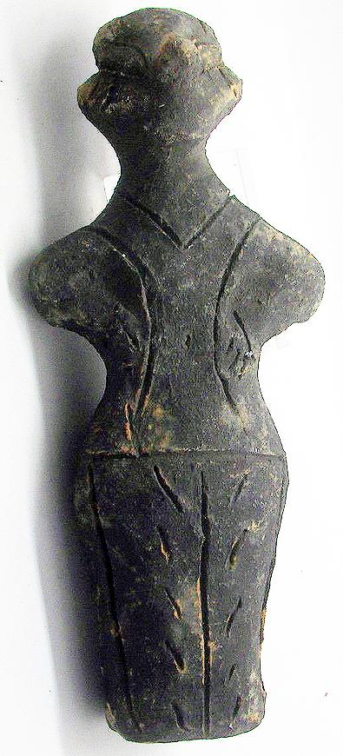 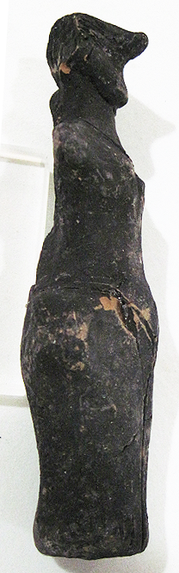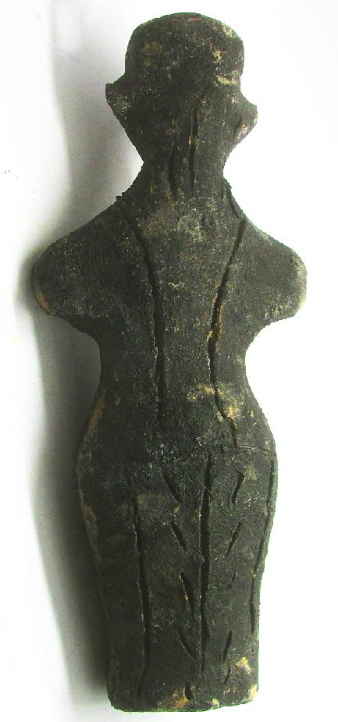

Figs. 1-3. Vinca-Neolithic-Ceramic-Female Anthropomorphic Figurine, 5500-4500 BCE

Formal Label: Vinca-Neolithic-Ceramic-Female Anthropomorphic Figurine, 5500-4500 BCE

Accession Number: A326

Formal Label: Vinča-Neolithic-Ceramic-Female Anthropomorphic Figurine, 5500-4500 BCE

**Display Description:**

The Vinča culture was named for its type site, Vinča-Belo Brdo tell or mound, on the right bank of the Danube River in Belgrade, Serbia.

Early phase anthropomorphic figurines from this site have triangular heads, flat bodies with short outstretched arms and closed legs. The treatment of facial and body features was done by simple incisions into the clay without modeling. Later phase anthropomorphic figurines are more polygonal, with more pronounced facial features, such as modeled noses and distinctive half-moon eyes and modeled arms. For both periods no indication of a mouth is present. Some theorize that these figurines are deities for ritual practice, while others see them as ancestral cult objects.

This Vinča ceramic anthropomorphic figurine is from the later period. It has a pronounced nose, and two heavily modeled, slanting, half-moon eyes, with parallel facial tattoos beneath. Although it has no discernible breasts, it wears long hair in the back and its lower body is covered by a flounced kulotte extending to the ground. No feet are discernible. It has a halter top is fastened by straps over the shoulders. Therefore, it is possible that this is a female.

**LC Classification:** GN776.2.V5

Date or Time Horizon: Middle Neolithic/Copper Age-5500-4500 BCE

Geographical Area: SE Europe

**Map, GPS coordinates:** 44°45′43″N 20°37′23″E (Vinča Belo-Brdo, Serbia)





Fig. 4. Map of the extent of Vinča culture. Adapted after Kaiser and Voytek (1983: 333, fig. 1) and Chapman (1981); from https://www.ucl.ac.uk/silva/rise-metallurgy-eurasia/images/5.1.jpg?hires

Fig. 5. Map of the Central Balkans. Beograd = Belgrade, Serbia, and the approximate location of the Vinča Belo-Brdo site. From http://drakenberg.weebly.com/uploads/6/7/4/7/6747442/9582880.jpg?578

Cultural Affiliation: Vinča Culture

Medium: Clay

Dimensions: H 135.55 mm, 5.34 in

Weight: 134 gm, 4 5/8 oz

Condition: original

Provenance: Michael Davies, 2 Hanover Court, Didcot, Oxfordshire, ox11 8nu, United Kingdom

**Discussion:**

The Vinča culture emerged at the inception of the Middle Neolithic/Copper or Chacolithic Age (5500-4500 BCE) with origins that are debated as either having derived from the earlier Starčevo culture (6200-4500 BCE) of the area, which has been reputed to have been the source of a Proto Indo-European language (PIE), or from migrations from a PIE homeland of a Kurgan or mound-building culture in the Pontic steppe north of the Black Sea (The Kurgan Hypothesis).

Vinča settlers initiated a cultural uniformity that they expressed in farming, making dark pottery fired under reducing conditions comprising zoomorphic and anthropomorphic figurines and making clay tablets with so-called Vinča symbols, which have the appearance of proto-writing (Winn Luca 2008: 26). The type site of the Vinča-Belo Brdo comprised 7 m of Vinča cultural debris overlying 2 m of the previous Starčevo culture. Elsewhere in Serbia and the western part of Romania large Vinča tell villages ranged up to 100 ha in size.



Fig. 6. The extent of the Starčevo culture (6200-4500 BCE) in southeast Europe. After https://upload.wikimedia.org/wikipedia/commons/thumb/e/ea/Starcevo_culture.png/450px-Starcevo_culture.png

Fig. 7. Overview of [Marija Gimbutas](https://commons.wikimedia.org/w/index.php?title=Marija_Gimbutas&action=edit&redlink=1)' [Kurgan](https://commons.wikimedia.org/w/index.php?title=Kurgan&action=edit&redlink=1) hypothesis showing the PIE migrations from the Pontic Steppes into southeastern Europe. Made by [en:User:Dbachmann](https://en.wikipedia.org/wiki/User:Dbachmann) and originally at [en:Image:Kurgan map.png](https://en.wikipedia.org/wiki/Image:Kurgan_map.png).

**References:**

Biagi, P. Gratuze, B. and Boucetta, S. 2007. “New data on the archaeological obsidians from Banat and Transylvania (Romania).” In M. Spataro and P. Biagi (eds.) *A short walk through the Balkans: The first farmers of the Carpathian basin and Adjacent regions*. Quaderno 12. Trieste: Societa per la preistoria e protoistoria della regione Friuli-Venezia Giulia, pp. 129-39.

Chapman, J. 1981. *The Vinča Culture of South East Europe. Studies in chronology, economy and society*. British Archaeological Reports, International Series 117, Oxford: Archeopress. 2v.

Gimbutas, Marija. 1970. “Proto-Indo-European Culture: The Kurgan Culture during the Fifth, Fourth, and Third Millennia B.C.” In Cardona, George; Hoenigswald, Henry M.; Senn, Alfred, Indo-European and Indo-Europeans: Papers Presented at the Third Indo-European Conference at the University of Pennsylvania. Philadelphia: University of Pennsylvania Press, pp. 155–197.

Haak, Wolfgang *et al*. 2015. “Massive migration from the steppe is a source for Indo-European languages in Europe.” bioRxiv preprint first posted online Feb. 10, 2015; doi: http://dx.doi.org/10.1101/013433 Now published in *Nature* doi: [10.1038/nature14317](http://dx.doi.org/10.1038/nature14317)

Holmberg, E.J. 1964. “The Appearance of Neolithic Black Burnished Ware in Mainland Greece,” *American Journal of Archaeology* 68(4): 343-8.

Kaiser, T. and B. Voytek. 1983. “Sedentism and economic change in the Balkan Neolithic,” *Journal of Anthropological Archaeology* 2(4): 323-353.

Luca, S. A. 2008. “The Neolithic and Eneolithic periods in Transylvania.” In Institute of Archaeomythology and Muzeul Brukenthal, *The Danube script: Neo-eneolithic writing in southeastern Europe* [exhibition catalogue]. Sebastopol, California, Institute of Archaeomythology, pp. 23-38,

Özdoğan, M. 2003. “The Prehistory of Northwestern Turkey - The synoptic overview of the latest evidence.” In D.V. Grammenos (ed.) *Recent Research in the Prehistory of the Balkans*. Thessaloniki: Archaeological Institute of Northern Greece and the Archaeological Receipts Fund, pp. 329- 68.

Thissen, L. (2001) “Time trajectories for the Neolithic of Central Anatolia, CANeW project,” http://www.canew.org/files/Thissen%20lecture.pdf, [23.11.2001]: 1-26.

─── (2007) “CANeW Central Anatolia and Cilicia 14C Chart, CANeW project,” http://www.canew.org/cachronobox.html, updated at 16.03.2007.

Vasic, Mīloje M. 1932-1936. *Preistoriska Vinča*. Beograd [Belgrade]: Državne Štamparije. 4 v.

Winn, Milton MacChesney. 1981. [*Pre-writing in Southeastern Europe: the sign system of the Vinča culture ca. 4000 B.C.*](http://www.worldcat.org/title/pre-writing-in-southeastern-europe-the-sgin-system-of-the-vinca-culture-ca-4000-bc/oclc/781534609&referer=brief_results) Calgary, Alberta: Western Publishers.

A319-EUR-Vinca-Neolithic-Ceramic-Female Anthropomorphic Figurine, 5500-4500 BCE

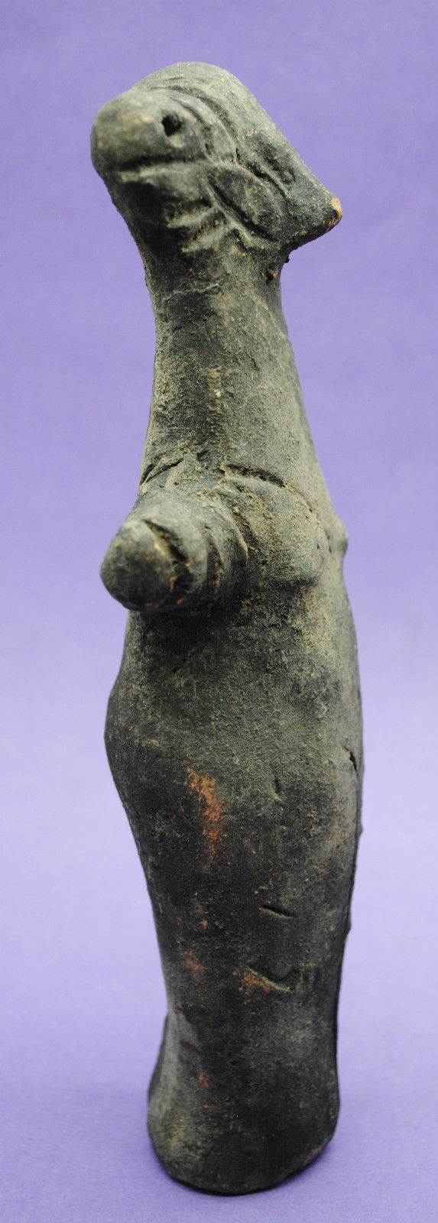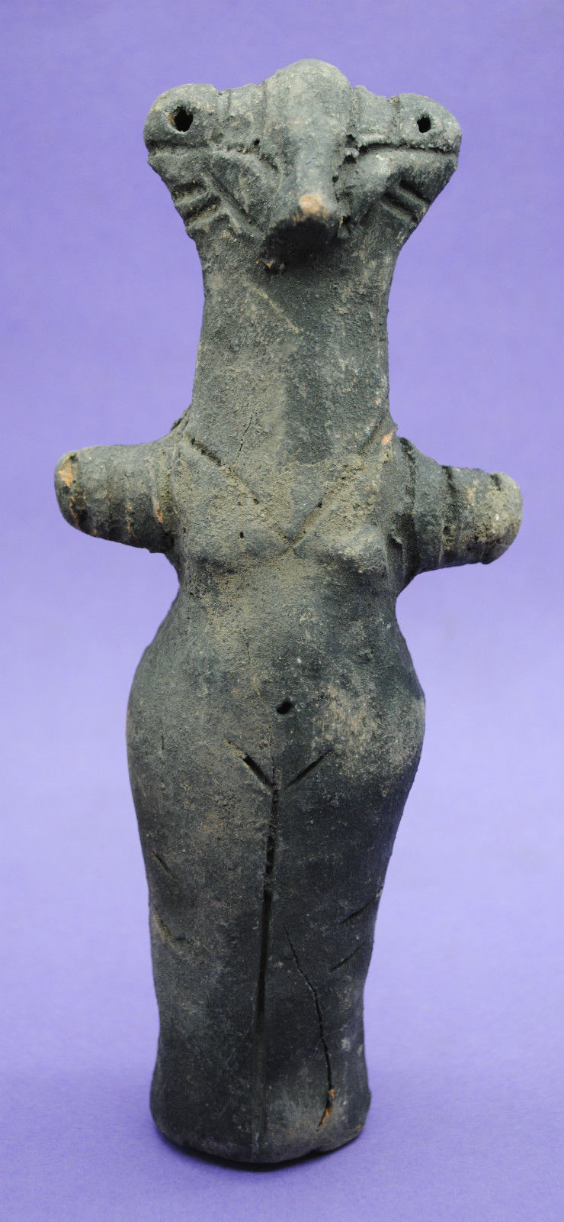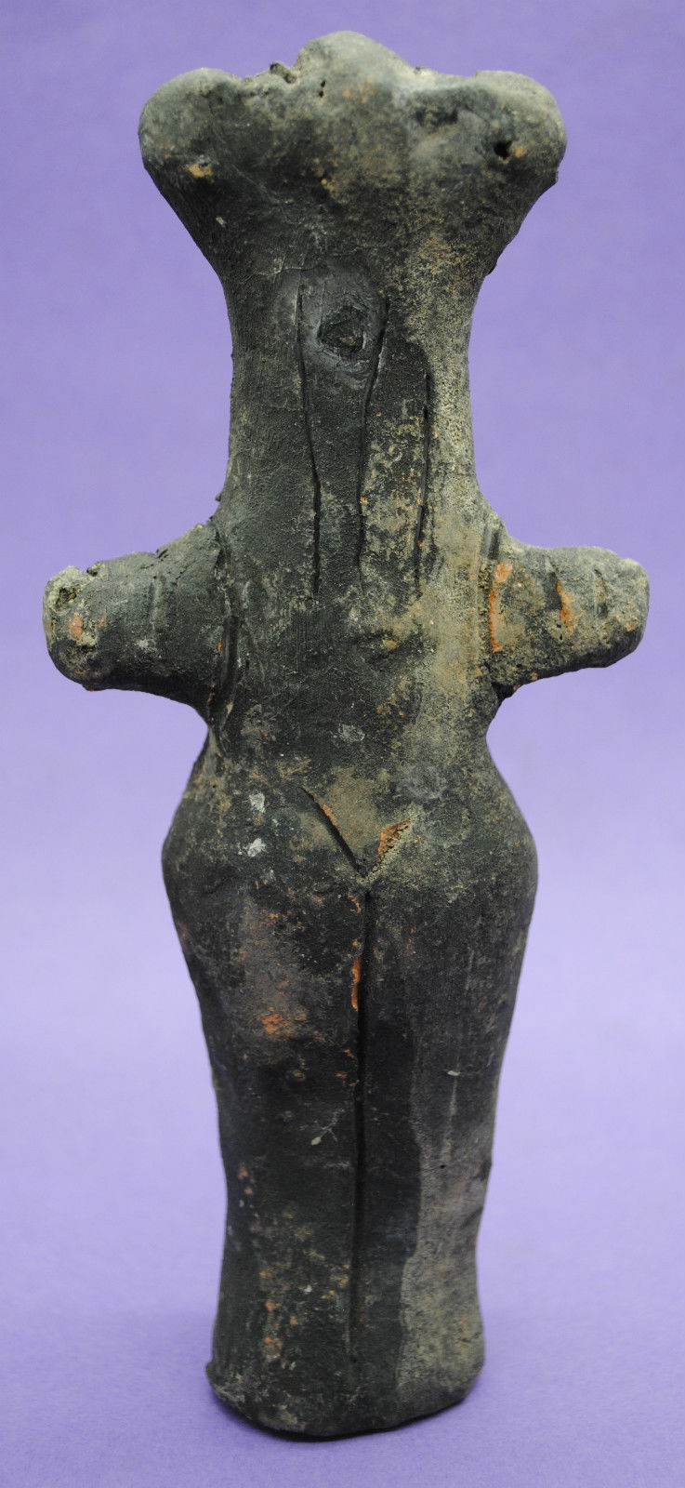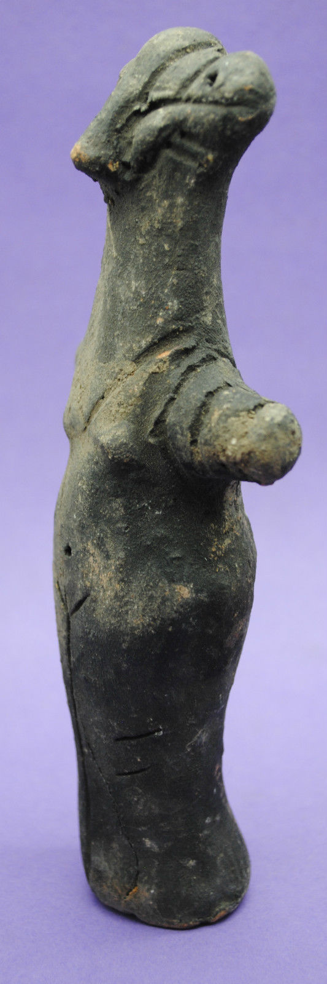

Figs. 1-4. Vinča-Neolithic-Ceramic-Female Anthropomorphic Figurine, 5500-4500 BCE

Formal Label: Vinča-Neolithic-Ceramic-Female Anthropomorphic Figurine, 5500-4500 BCE

**Display Description:**

The Vinča culture was named for its type site, Vinča-Belo Brdo tell or mound, on the right bank of the Danube River in Belgrade, Serbia.

Early phase anthropomorphic figurines from this site have triangular heads, flat bodies with short outstretched arms and closed legs. The treatment of facial and body features was done by simple incisions into the clay without modeling. Later phase anthropomorphic figurines are more polygonal, with more pronounced facial features, such as modeled noses and distinctive half-moon eyes and modeled arms. For both periods no indication of a mouth is present. Some theorize that these figurines are deities for ritual practice, while others see them as ancestral cult objects.

This Vinča ceramic female anthropomorphic figurine is from the later period, and it is anomalous in several ways. It has a pronounced straight nose, and eyes that are set high on the head, are marked by punctates and are bordered by incisions. It also has a smiling, closed mouth, with parallel lines (wrinkles?) extending from its sides. It has small, modeled breasts and wears long hair in the back that extends beyond its shoulders. Its lower body is covered by a straight kulotte extending to the ground from below the navel which is marked by a punctate. No feet are discernible. It has a short-sleeve “V”-neck top fastened over the shoulders. On each arm are three bracelets.

Accession Number: A319

**LC Classification:** GN776.2.V5

Date or Time Horizon: Middle Neolithic/Copper Age-5500-4500 BCE.

Geographical Area: SE Europe

**Map, GPS coordinates:** 44°45′43″N 20°37′23″E (Vinča Belo-Brdo, Serbia)





Fig. 5. Map of the extent of Vinča culture. Adapted after Kaiser and Voytek (1983: 333, fig. 1) and Chapman (1981); from https://www.ucl.ac.uk/silva/rise-metallurgy-eurasia/images/5.1.jpg?hires

Fig. 6. Map of the Central Balkans. Beograd = Belgrade, Serbia, and the approximate location of the Vinča Belo-Brdo site. From http://drakenberg.weebly.com/uploads/6/7/4/7/6747442/9582880.jpg?578

Cultural Affiliation: Vinča Culture

Medium: clay

Dimensions: H 174.74 mm, 6.76 in

Weight: 258 gm, 9 oz

Provenance: Anglo-Antiquities, 33 Medlock Grove, Didcot, Oxfordshire, ox11 7xy, United Kingdom

**Discussion:**

The Vinča culture emerged at the inception of the Middle Neolithic/Copper or Chacolithic Age (5500-4500 BCE) with origins that are debated as either having derived from the earlier Starčevo culture (6200-4500 BCE) of the area, which has been reputed to have been the source of a Proto Indo-European language (PIE), or from migrations from a PIE homeland of a Kurgan or mound-building culture in the Pontic steppe north of the Black Sea (The Kurgan Hypothesis).

Vinča settlers initiated a cultural uniformity that they expressed in farming, making dark pottery fired under reducing conditions comprising zoomorphic and anthropomorphic figurines and making clay tablets with so-called Vinča symbols, which have the appearance of proto-writing (Winn Luca 2008: 26). The type site of the Vinča-Belo Brdo comprised 7 m of Vinča cultural debris overlying 2 m of the previous Starčevo culture. Elsewhere in Serbia and the western part of Romania large Vinča tell villages ranged up to 100 ha in size.



Fig. 7. The extent of the Starčevo culture (6200-4500 BCE) in southeast Europe. After https://upload.wikimedia.org/wikipedia/commons/thumb/e/ea/Starcevo_culture.png/450px-Starcevo_culture.png

Fig.8. Overview of [Marija Gimbutas](https://commons.wikimedia.org/w/index.php?title=Marija_Gimbutas&action=edit&redlink=1)' [Kurgan](https://commons.wikimedia.org/w/index.php?title=Kurgan&action=edit&redlink=1) hypothesis showing the PIE migrations from the Pontic Steppes into southeastern Europe. Made by [en:User:Dbachmann](https://en.wikipedia.org/wiki/User:Dbachmann) and originally at [en:Image:Kurgan map.png](https://en.wikipedia.org/wiki/Image:Kurgan_map.png).

**References:**

Biagi, P. Gratuze, B. and Boucetta, S. 2007. “New data on the archaeological obsidians from Banat and Transylvania (Romania).” In M. Spataro and P. Biagi (eds.) *A short walk through the Balkans: The first farmers of the Carpathian basin and Adjacent regions*. Quaderno 12. Trieste: Societa per la preistoria e protoistoria della regione Friuli-Venezia Giulia, pp. 129-39.

Chapman, J. 1981. *The Vinča Culture of South East Europe. Studies in chronology, economy and society*. British Archaeological Reports, International Series 117, Oxford: Archeopress. 2v.

Gimbutas, Marija. 1970. “Proto-Indo-European Culture: The Kurgan Culture during the Fifth, Fourth, and Third Millennia B.C.” In Cardona, George; Hoenigswald, Henry M.; Senn, Alfred, Indo-European and Indo-Europeans: Papers Presented at the Third Indo-European Conference at the University of Pennsylvania. Philadelphia: University of Pennsylvania Press, pp. 155–197.

Haak, Wolfgang *et al*. 2015. “Massive migration from the steppe is a source for Indo-European languages in Europe.” bioRxiv preprint first posted online Feb. 10, 2015; doi: http://dx.doi.org/10.1101/013433 Now published in *Nature* doi: [10.1038/nature14317](http://dx.doi.org/10.1038/nature14317)

Holmberg, E.J. 1964. “The Appearance of Neolithic Black Burnished Ware in Mainland Greece,” *American Journal of Archaeology* 68(4): 343-8.

Kaiser, T. and B. Voytek. 1983. “Sedentism and economic change in the Balkan Neolithic,” *Journal of Anthropological Archaeology* 2(4): 323-353.

Luca, S. A. 2008. “The Neolithic and Eneolithic periods in Transylvania.” In Institute of Archaeomythology and Muzeul Brukenthal, *The Danube script: Neo-eneolithic writing in southeastern Europe* [exhibition catalogue]. Sebastopol, California, Institute of Archaeomythology, pp. 23-38,

Özdoğan, M. 2003. “The Prehistory of Northwestern Turkey - The synoptic overview of the latest evidence.” In D.V. Grammenos (ed.) *Recent Research in the Prehistory of the Balkans*. Thessaloniki: Archaeological Institute of Northern Greece and the Archaeological Receipts Fund, pp. 329- 68.

Thissen, L. (2001) “Time trajectories for the Neolithic of Central Anatolia, CANeW project,” http://www.canew.org/files/Thissen%20lecture.pdf, [23.11.2001]: 1-26.

─── (2007) “CANeW Central Anatolia and Cilicia 14C Chart, CANeW project,” http://www.canew.org/cachronobox.html, updated at 16.03.2007.

Vasic, Mīloje M. 1932-1936. *Preistoriska Vinča*. Beograd [Belgrade]: Državne Štamparije. 4 v.

Winn, Milton MacChesney. 1981. [*Pre-writing in Southeastern Europe: the sign system of the Vinča culture ca. 4000 B.C.*](http://www.worldcat.org/title/pre-writing-in-southeastern-europe-the-sgin-system-of-the-vinca-culture-ca-4000-bc/oclc/781534609&referer=brief_results) Calgary, Alberta: Western Publishers.

A332-.EUR-Vinca-Neolithic-Ceramic-Female Anthropomorphic Figurine, 5500-4500 BCE

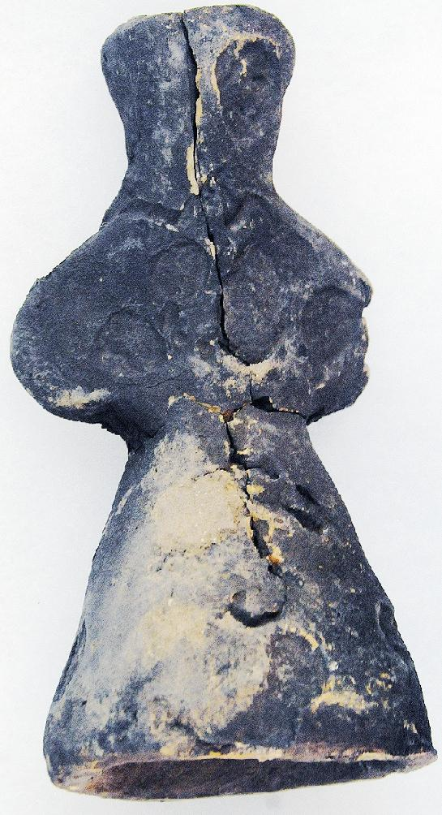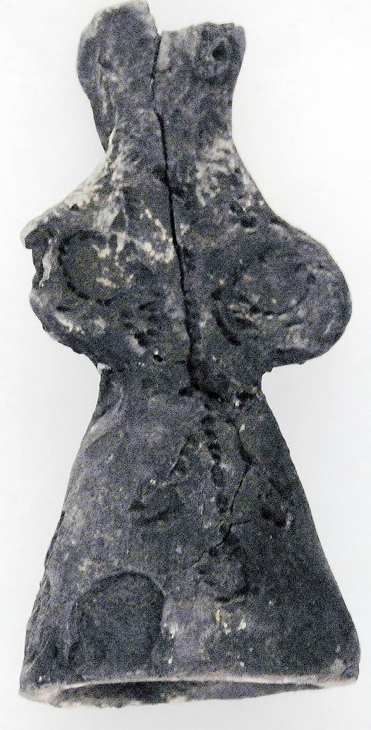 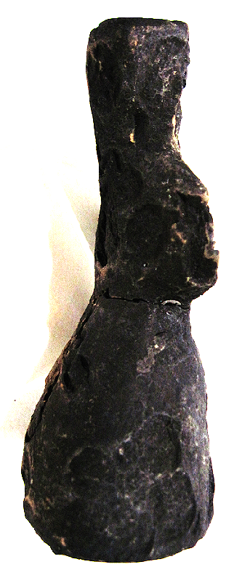

Figs. 1-3. Vinča-Neolithic-Ceramic-Female Anthropomorphic Figurine, 5500-4500 BCE

Case no.: 3

Accession Number: A332

Formal Label: Vinča-Neolithic-Ceramic-Female Anthropomorphic Figurine, 5500-4500 BCE

**Display Description:**

The Vinča culture was named for its type site, Vinča-Belo Brdo tell or mound, on the right bank of the Danube River in Belgrade, Serbia.

Early phase anthropomorphic figurines from this site have triangular heads, flat bodies with short outstretched arms and closed legs. The treatment of facial and body features was done by simple incisions into the clay without modeling. Later phase anthropomorphic figurines are more polygonal, with more pronounced facial features, such as modeled noses and distinctive half-moon eyes and modeled arms. For both periods no indication of a mouth is present. Some theorize that these figurines are deities for ritual practice, while others see them as ancestral cult objects.

This blackened Vinča ceramic female anthropomorphic figurine is from the later period, and it is anomalous in several ways. It has an inverted cone-shaped head and a cone-shaped lower body. Its left eye is circular and incised. A portion of its right eye has spalled off. There is no nose or mouth. Its arms are modeled as though resting on the hips. Its body is covered by a full-length dress or kulotte extending to the ground, since a line of dots down the front and back terminating in a circle may indicate that the legs are separated. No feet are discernible.

**LC Classification:** GN776.2.V5

Date or Time Horizon: Middle Neolithic/Copper Age-5500-4500 BCE

Geographical Area: SE Europe

**Map, GPS coordinates:** 44°45′43″N 20°37′23″E (Vinča Belo-Brdo, Serbia)





Fig. 4. Map of the extent of Vinča culture. Adapted after Kaiser and Voytek (1983: 333, fig. 1) and Chapman (1981); from https://www.ucl.ac.uk/silva/rise-metallurgy-eurasia/images/5.1.jpg?hires

Fig. 5. Map of the Central Balkans. Beograd = Belgrade, Serbia, and the approximate location of the Vinča Belo-Brdo site. From http://drakenberg.weebly.com/uploads/6/7/4/7/6747442/9582880.jpg?578

Cultural Affiliation: Vinča Culture

Medium: Clay

Dimensions: H 123.68 mm, 4.87 in

Weight: 157 gm, 5.5 oz

Condition: original

Provenance: Anglo-Antiquities, 33 Medlock Grove, Didcot, Oxfordshire, ox11 7xy, United Kingdom

**Discussion:**

The Vinča culture emerged at the inception of the Middle Neolithic/Copper or Chacolithic Age (5500-4500 BCE) with origins that are debated as either having derived from the earlier Starčevo culture (6200-4500 BCE) of the area, which has been reputed to have been the source of a Proto Indo-European language (PIE), or from migrations from a PIE homeland of a Kurgan or mound-building culture in the Pontic steppe north of the Black Sea (The Kurgan Hypothesis).

Vinča settlers initiated a cultural uniformity that they expressed in farming, making dark pottery fired under reducing conditions comprising zoomorphic and anthropomorphic figurines and making clay tablets with so-called Vinča symbols, which have the appearance of proto-writing (Winn Luca 2008: 26). The type site of the Vinča-Belo Brdo comprised 7 m of Vinča cultural debris overlying 2 m of the previous Starčevo culture. Elsewhere in Serbia and the western part of Romania large Vinča tell villages ranged up to 100 ha in size.



Fig. 6. The extent of the Starčevo culture (6200-4500 BCE) in southeast Europe. After https://upload.wikimedia.org/wikipedia/commons/thumb/e/ea/Starcevo_culture.png/450px-Starcevo_culture.png

Fig. 7. Overview of [Marija Gimbutas](https://commons.wikimedia.org/w/index.php?title=Marija_Gimbutas&action=edit&redlink=1)' [Kurgan](https://commons.wikimedia.org/w/index.php?title=Kurgan&action=edit&redlink=1) hypothesis showing the PIE migrations from the Pontic Steppes into southeastern Europe. Made by [en:User:Dbachmann](https://en.wikipedia.org/wiki/User:Dbachmann) and originally at [en:Image:Kurgan map.png](https://en.wikipedia.org/wiki/Image:Kurgan_map.png).

**References:**

Biagi, P. Gratuze, B. and Boucetta, S. 2007. “New data on the archaeological obsidians from Banat and Transylvania (Romania).” In M. Spataro and P. Biagi (eds.) *A short walk through the Balkans: The first farmers of the Carpathian basin and Adjacent regions*. Quaderno 12. Trieste: Societa per la preistoria e protoistoria della regione Friuli-Venezia Giulia, pp. 129-39.

Chapman, J. 1981. *The Vinča Culture of South East Europe. Studies in chronology, economy and society*. British Archaeological Reports, International Series 117, Oxford: Archeopress. 2v.

Gimbutas, Marija. 1970. “Proto-Indo-European Culture: The Kurgan Culture during the Fifth, Fourth, and Third Millennia B.C.” In Cardona, George; Hoenigswald, Henry M.; Senn, Alfred, Indo-European and Indo-Europeans: Papers Presented at the Third Indo-European Conference at the University of Pennsylvania. Philadelphia: University of Pennsylvania Press, pp. 155–197.

Haak, Wolfgang *et al*. 2015. “Massive migration from the steppe is a source for Indo-European languages in Europe.” bioRxiv preprint first posted online Feb. 10, 2015; doi: http://dx.doi.org/10.1101/013433 Now published in *Nature* doi: [10.1038/nature14317](http://dx.doi.org/10.1038/nature14317)

Holmberg, E.J. 1964. “The Appearance of Neolithic Black Burnished Ware in Mainland Greece,” *American Journal of Archaeology* 68(4): 343-8.

Kaiser, T. and B. Voytek. 1983. “Sedentism and economic change in the Balkan Neolithic,” *Journal of Anthropological Archaeology* 2(4): 323-353.

Luca, S. A. 2008. “The Neolithic and Eneolithic periods in Transylvania.” In Institute of Archaeomythology and Muzeul Brukenthal, *The Danube script: Neo-eneolithic writing in southeastern Europe* [exhibition catalogue]. Sebastopol, California, Institute of Archaeomythology, pp. 23-38,

Özdoğan, M. 2003. “The Prehistory of Northwestern Turkey - The synoptic overview of the latest evidence.” In D.V. Grammenos (ed.) *Recent Research in the Prehistory of the Balkans*. Thessaloniki: Archaeological Institute of Northern Greece and the Archaeological Receipts Fund, pp. 329- 68.

Thissen, L. (2001) “Time trajectories for the Neolithic of Central Anatolia, CANeW project,” http://www.canew.org/files/Thissen%20lecture.pdf, [23.11.2001]: 1-26.

─── (2007) “CANeW Central Anatolia and Cilicia 14C Chart, CANeW project,” http://www.canew.org/cachronobox.html, updated at 16.03.2007.

Vasic, Mīloje M. 1932-1936. *Preistoriska Vinča*. Beograd [Belgrade]: Državne Štamparije. 4 v.

Winn, Milton MacChesney. 1981. [*Pre-writing in Southeastern Europe: the sign system of the Vinča culture ca. 4000 B.C.*](http://www.worldcat.org/title/pre-writing-in-southeastern-europe-the-sgin-system-of-the-vinca-culture-ca-4000-bc/oclc/781534609&referer=brief_results) Calgary, Alberta: Western Publishers.

A322-EUR-Vinca-Neolithic-Ceramic-Anthropomorphic Figurine, 5500-4500 BCE

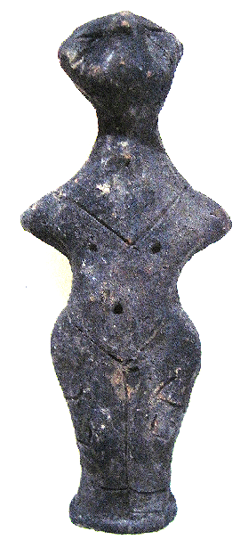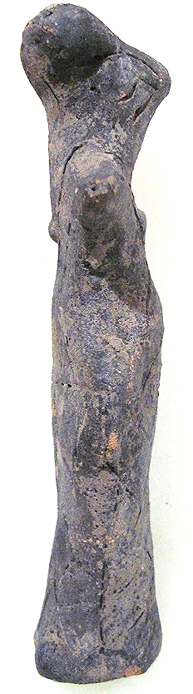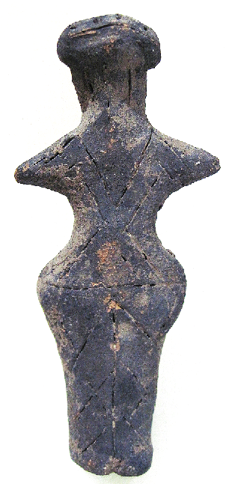

Figs. 1-3. Vinča-Neolithic-Ceramic-Female Anthropomorphic Figurine, 5500-4500 BCE

Case no.: 3

Accession Number: A322

Formal Label: Vinča-Neolithic-Ceramic-Female Anthropomorphic Figurine, 5500-4500 BCE

**Display Description:**

The Vinča culture was named for its type site, Vinča-Belo Brdo tell or mound, on the right bank of the Danube River in Belgrade, Serbia.

Early phase anthropomorphic figurines from this site have triangular heads, flat bodies with short outstretched arms and closed legs. The treatment of facial and body features was done by simple incisions into the clay without modeling. Later phase anthropomorphic figurines are more polygonal, with more pronounced facial features, such as modeled noses and distinctive half-moon eyes and modeled arms. For both periods no indication of a mouth is present. Some theorize that these figurines are deities for ritual practice, while others see them as ancestral cult objects.

This Vinča ceramic female anthropomorphic figurine is from the later period, and has a pronounced nose, and eyes that are set high on the head, are marked by incisions and. Its breasts and navel are marked by punctates and it wears long hair in the back that extends to its shoulders. Its lower body is covered by a straight kulotte extending to the ground from below the navel. Footwear may be indicated. It has a “V”-neck top.

**LC Classification:** GN776.2.V5

Date or Time Horizon: Middle Neolithic/Copper Age-5500-4500 BCE.

Geographical Area: SE Europe

**Map, GPS coordinates:** 44°45′43″N 20°37′23″E (Vinča Belo-Brdo, Serbia)





Fig. Map of the extent of Vinča culture. Adapted after Kaiser and Voytek (1983: 333, fig. 1) and Chapman (1981); from https://www.ucl.ac.uk/silva/rise-metallurgy-eurasia/images/5.1.jpg?hires

Fig. Map of the Central Balkans. Beograd = Belgrade, Serbia, and the approximate location of the Vinča Belo-Brdo site. From http://drakenberg.weebly.com/uploads/6/7/4/7/6747442/9582880.jpg?578

Cultural Affiliation: Vinča Culture

Medium: clay

Dimensions: H 162.82 mm, 6.41 in

Weight: 258 gm, 9 oz

Provenance: Anglo-Antiquities, 33 Medlock Grove, Didcot, Oxfordshire, ox11 7xy, United Kingdom

**Discussion:**

The Vinča culture emerged at the inception of the Middle Neolithic/Copper or Chacolithic Age (5500-4500 BCE) with origins that are debated as either having derived from the earlier Starčevo culture (6200-4500 BCE) of the area, which has been reputed to have been the source of a Proto Indo-European language (PIE), or from migrations from a PIE homeland of a Kurgan or mound-building culture in the Pontic steppe north of the Black Sea (The Kurgan Hypothesis).

Vinča settlers initiated a cultural uniformity that they expressed in farming, making dark pottery fired under reducing conditions comprising zoomorphic and anthropomorphic figurines and making clay tablets with so-called Vinča symbols, which have the appearance of proto-writing (Winn Luca 2008: 26). The type site of the Vinča-Belo Brdo comprised 7 m of Vinča cultural debris overlying 2 m of the previous Starčevo culture. Elsewhere in Serbia and the western part of Romania large Vinča tell villages ranged up to 100 ha in size.



Fig. The extent of the Starčevo culture (6200-4500 BCE) in southeast Europe. After https://upload.wikimedia.org/wikipedia/commons/thumb/e/ea/Starcevo_culture.png/450px-Starcevo_culture.png

Fig. Overview of [Marija Gimbutas](https://commons.wikimedia.org/w/index.php?title=Marija_Gimbutas&action=edit&redlink=1)' [Kurgan](https://commons.wikimedia.org/w/index.php?title=Kurgan&action=edit&redlink=1) hypothesis showing the PIE migrations from the Pontic Steppes into southeastern Europe. Made by [en:User:Dbachmann](https://en.wikipedia.org/wiki/User:Dbachmann) and originally at [en:Image:Kurgan map.png](https://en.wikipedia.org/wiki/Image:Kurgan_map.png).

**References:**

Biagi, P. Gratuze, B. and Boucetta, S. 2007. “New data on the archaeological obsidians from Banat and Transylvania (Romania).” In M. Spataro and P. Biagi (eds.) *A short walk through the Balkans: The first farmers of the Carpathian basin and Adjacent regions*. Quaderno 12. Trieste: Societa per la preistoria e protoistoria della regione Friuli-Venezia Giulia, pp. 129-39.

Chapman, J. 1981. *The Vinča Culture of South East Europe. Studies in chronology, economy and society*. British Archaeological Reports, International Series 117, Oxford: Archeopress. 2v.

Gimbutas, Marija. 1970. “Proto-Indo-European Culture: The Kurgan Culture during the Fifth, Fourth, and Third Millennia B.C.” In Cardona, George; Hoenigswald, Henry M.; Senn, Alfred, Indo-European and Indo-Europeans: Papers Presented at the Third Indo-European Conference at the University of Pennsylvania. Philadelphia: University of Pennsylvania Press, pp. 155–197.

Haak, Wolfgang *et al*. 2015. “Massive migration from the steppe is a source for Indo-European languages in Europe.” bioRxiv preprint first posted online Feb. 10, 2015; doi: http://dx.doi.org/10.1101/013433 Alsopublished in *Nature* doi: [10.1038/nature14317](http://dx.doi.org/10.1038/nature14317)

Holmberg, E.J. 1964. “The Appearance of Neolithic Black Burnished Ware in Mainland Greece,” *American Journal of Archaeology* 68(4): 343-8.

Kaiser, T. and B. Voytek. 1983. “Sedentism and economic change in the Balkan Neolithic,” *Journal of Anthropological Archaeology* 2(4): 323-353.

Luca, S. A. 2008. “The Neolithic and Eneolithic periods in Transylvania.” In Institute of Archaeomythology and Muzeul Brukenthal, *The Danube script: Neo-eneolithic writing in southeastern Europe* [exhibition catalogue]. Sebastopol, California, Institute of Archaeomythology, pp. 23-38.

Özdoğan, M. 2003. “The Prehistory of Northwestern Turkey - The synoptic overview of the latest evidence.” In D.V. Grammenos (ed.) *Recent Research in the Prehistory of the Balkans*. Thessaloniki: Archaeological Institute of Northern Greece and the Archaeological Receipts Fund, pp. 329- 68.

Thissen, L. (2001) “Time trajectories for the Neolithic of Central Anatolia, CANeW project,” http://www.canew.org/files/Thissen%20lecture.pdf, [23.11.2001]: 1-26.

─── (2007) “CANeW Central Anatolia and Cilicia 14C Chart, CANeW project,” http://www.canew.org/cachronobox.html, updated at 16.03.2007.

Vasic, Mīloje M. 1932-1936. *Preistoriska Vinča*. Beograd [Belgrade]: Državne Štamparije. 4 v.

Winn, Milton MacChesney. 1981. [*Pre-writing in Southeastern Europe: the sign system of the Vinča culture ca. 4000 B.C.*](http://www.worldcat.org/title/pre-writing-in-southeastern-europe-the-sgin-system-of-the-vinca-culture-ca-4000-bc/oclc/781534609&referer=brief_results) Calgary, Alberta: Western Publishers.

A320-EUR-Vinca-Neolithic-Ceramic-Female Anthropomorphic Figurine, 5500-4500 BCE

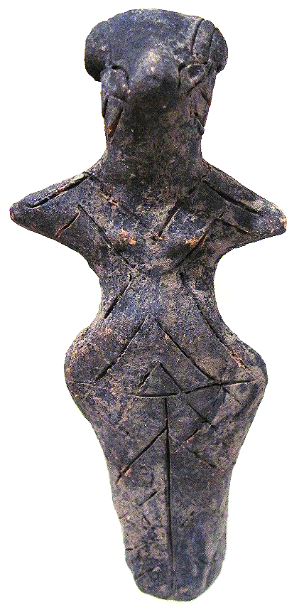 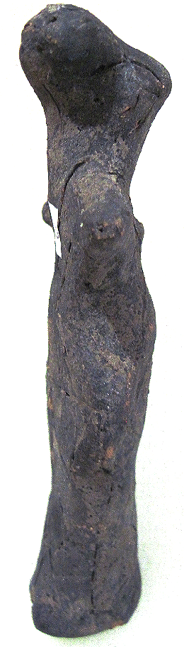 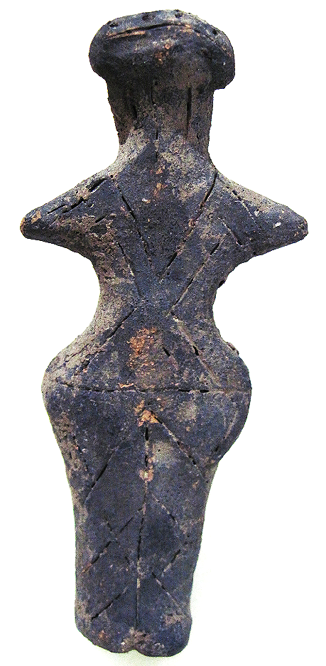

Figs. 1-3. Vinča-Neolithic-Ceramic-Female Anthropomorphic Figurine, 5500-4500 BCE

Case no.: 3

Accession Number: 320

Formal Label: Vinča-Neolithic-Ceramic-Female Anthropomorphic Figurine, 5500-4500 BCE

**Display Description:**

The Vinča culture was named for its type site, Vinča-Belo Brdo tell or mound, on the right bank of the Danube River in Belgrade, Serbia.

Early phase anthropomorphic figurines from this site have triangular heads, flat bodies with short outstretched arms and closed legs. The treatment of facial and body features was done by simple incisions into the clay without modeling. Later phase anthropomorphic figurines are more polygonal, with more pronounced facial features, such as modeled noses and distinctive half-moon eyes and modeled arms. For both periods no indication of a mouth is present. Some theorize that these figurines are deities for ritual practice, while others see them as ancestral cult objects.

This Vinča ceramic female anthropomorphic figurine is from the later period, and has a pronounced nose, and eyes that are set midway on the head, are marked by incisions. Its small breasts are modeled. It wears hair that extends to the nape of its neck. Its upper body is covered by a blouse with sleeves and a design of chevrons. Its lower body continues this design in a straight kulotte extending to the ground from the waist. Feet are not indicated.

**LC Classification:** GN776.2.V5

Date or Time Horizon: Middle Neolithic/Copper Age-5500-4500 BCE.

Geographical Area: SE Europe

**Map, GPS coordinates:** 44°45′43″N 20°37′23″E (Vinča Belo-Brdo, Serbia)





Fig.4. Map of the extent of Vinča culture. Adapted after Kaiser and Voytek (1983: 333, fig. 1) and Chapman (1981); from https://www.ucl.ac.uk/silva/rise-metallurgy-eurasia/images/5.1.jpg?hires

Fig. 5. Map of the Central Balkans. Beograd = Belgrade, Serbia, and the approximate location of the Vinča Belo-Brdo site. From http://drakenberg.weebly.com/uploads/6/7/4/7/6747442/9582880.jpg?578

Cultural Affiliation: Vinča Culture

Medium: clay

Dimensions: H 164.23 mm, 6.47 in

Weight: 214 gm, 7.5 oz

Provenance: Anglo-Antiquities, 33 Medlock Grove, Didcot, Oxfordshire, ox11 7xy, United Kingdom

**Discussion:**

The Vinča culture emerged at the inception of the Middle Neolithic/Copper or Chacolithic Age (5500-4500 BCE) with origins that are debated as either having derived from the earlier Starčevo culture (6200-4500 BCE) of the area, which has been reputed to have been the source of a Proto Indo-European language (PIE), or from migrations from a PIE homeland of a Kurgan or mound-building culture in the Pontic steppe north of the Black Sea (The Kurgan Hypothesis).

Vinča settlers initiated a cultural uniformity that they expressed in farming, making dark pottery fired under reducing conditions comprising zoomorphic and anthropomorphic figurines and making clay tablets with so-called Vinča symbols, which have the appearance of proto-writing (Winn Luca 2008: 26). The type site of the Vinča-Belo Brdo comprised 7 m of Vinča cultural debris overlying 2 m of the previous Starčevo culture. Elsewhere in Serbia and the western part of Romania large Vinča tell villages ranged up to 100 ha in size.



Fig. 6. The extent of the Starčevo culture (6200-4500 BCE) in southeast Europe. After https://upload.wikimedia.org/wikipedia/commons/thumb/e/ea/Starcevo_culture.png/450px-Starcevo_culture.png

Fig. 7. Overview of [Marija Gimbutas](https://commons.wikimedia.org/w/index.php?title=Marija_Gimbutas&action=edit&redlink=1)' [Kurgan](https://commons.wikimedia.org/w/index.php?title=Kurgan&action=edit&redlink=1) hypothesis showing the PIE migrations from the Pontic Steppes into southeastern Europe. Made by [en:User:Dbachmann](https://en.wikipedia.org/wiki/User:Dbachmann) and originally at [en:Image:Kurgan map.png](https://en.wikipedia.org/wiki/Image:Kurgan_map.png).

**References:**

Biagi, P. Gratuze, B. and Boucetta, S. 2007. “New data on the archaeological obsidians from Banat and Transylvania (Romania).” In M. Spataro and P. Biagi (eds.) *A short walk through the Balkans: The first farmers of the Carpathian basin and Adjacent regions*. Quaderno 12. Trieste: Societa per la preistoria e protoistoria della regione Friuli-Venezia Giulia, pp. 129-39.

Chapman, J. 1981. *The Vinča Culture of South East Europe. Studies in chronology, economy and society*. British Archaeological Reports, International Series 117, Oxford: Archeopress. 2v.

Gimbutas, Marija. 1970. “Proto-Indo-European Culture: The Kurgan Culture during the Fifth, Fourth, and Third Millennia B.C.” In Cardona, George; Hoenigswald, Henry M.; Senn, Alfred, Indo-European and Indo-Europeans: Papers Presented at the Third Indo-European Conference at the University of Pennsylvania. Philadelphia: University of Pennsylvania Press, pp. 155–197.

Haak, Wolfgang *et al*. 2015. “Massive migration from the steppe is a source for Indo-European languages in Europe.” bioRxiv preprint first posted online Feb. 10, 2015; doi: http://dx.doi.org/10.1101/013433 Also published in *Nature* doi: [10.1038/nature14317](http://dx.doi.org/10.1038/nature14317)

Holmberg, E.J. 1964. “The Appearance of Neolithic Black Burnished Ware in Mainland Greece,” *American Journal of Archaeology* 68(4): 343-8.

Kaiser, T. and B. Voytek. 1983. “Sedentism and economic change in the Balkan Neolithic,” *Journal of Anthropological Archaeology* 2(4): 323-353.

Luca, S. A. 2008. “The Neolithic and Eneolithic periods in Transylvania.” In Institute of Archaeomythology and Muzeul Brukenthal, *The Danube script: Neo-eneolithic writing in southeastern Europe* [exhibition catalogue]. Sebastopol, California, Institute of Archaeomythology, pp. 23-38.

Özdoğan, M. 2003. “The Prehistory of Northwestern Turkey - The synoptic overview of the latest evidence.” In D.V. Grammenos (ed.) *Recent Research in the Prehistory of the Balkans*. Thessaloniki: Archaeological Institute of Northern Greece and the Archaeological Receipts Fund, pp. 329- 68.

Thissen, L. (2001) “Time trajectories for the Neolithic of Central Anatolia, CANeW project,” http://www.canew.org/files/Thissen%20lecture.pdf, [23.11.2001]: 1-26.

─── (2007) “CANeW Central Anatolia and Cilicia 14C Chart, CANeW project,” http://www.canew.org/cachronobox.html, updated at 16.03.2007.

Vasic, Mīloje M. 1932-1936. *Preistoriska Vinča*. Beograd [Belgrade]: Državne Štamparije. 4 v.

Winn, Milton MacChesney. 1981. [*Pre-writing in Southeastern Europe: the sign system of the Vinča culture ca. 4000 B.C.*](http://www.worldcat.org/title/pre-writing-in-southeastern-europe-the-sgin-system-of-the-vinca-culture-ca-4000-bc/oclc/781534609&referer=brief_results) Calgary, Alberta: Western Publishers.

A330-EUR-Vinca-Neolithic-Ceramic-Anthropomorphic Figurine, 5500-4500 BCE

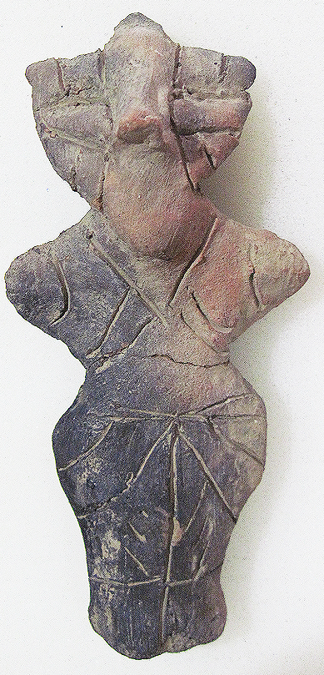 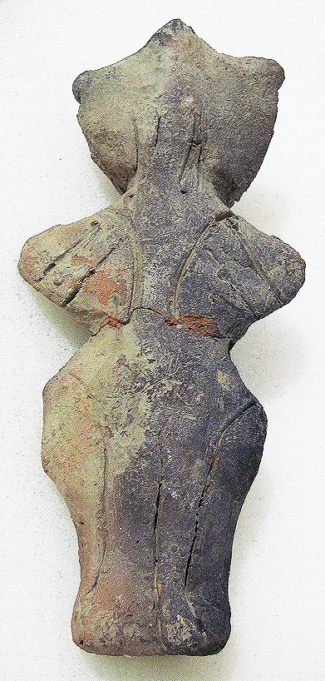 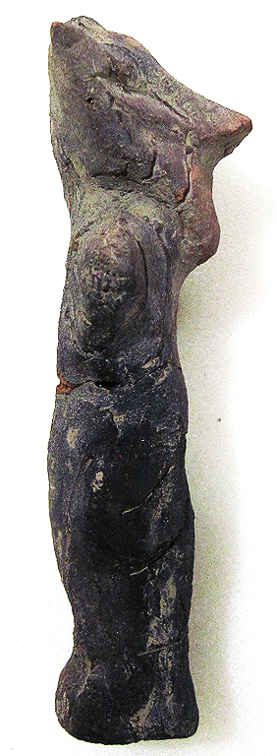

Figs. 1-3. Vinča-Neolithic-Ceramic-Male Anthropomorphic Figurine, 5500-4500 BCE

Case no.: 3

Accession Number: 330

Formal Label: Vinča-Neolithic-Ceramic-Male Anthropomorphic Figurine, 5500-4500 BCE

**Display Description:**

The Vinča culture was named for its type site, Vinča-Belo Brdo tell or mound, on the right bank of the Danube River in Belgrade, Serbia.

Early phase anthropomorphic figurines from this site have triangular heads, flat bodies with short outstretched arms and closed legs. The treatment of facial and body features was done by simple incisions into the clay without modeling. Later phase anthropomorphic figurines are more polygonal, with more pronounced facial features, such as modeled noses and distinctive half-moon eyes and modeled arms. For both periods no indication of a mouth is present. Some theorize that these figurines are deities for ritual practice, while others see them as ancestral cult objects.

This Vinča male anthropomorphic figurine is from the later period, and has a pronounced nose and a beard that extends below the chin. No mouth is indicated. Its eyes are large and oblong and are set midway on the head and are distinctly modeled. Its hair extends to the nape of its neck. Its upper body is covered by a sleeveless blouse and a design of chevrons. Its lower body continues this design in a straight kulotte extending below the knees from the waist. Feet are not indicated.

**LC Classification:** GN776.2.V5

Date or Time Horizon: Middle Neolithic/Copper Age-5500-4500 BCE.

Geographical Area: SE Europe

**Map, GPS coordinates:** 44°45′43″N 20°37′23″E (Vinča Belo-Brdo, Serbia)





Fig. 4. Map of the extent of Vinča culture. Adapted after Kaiser and Voytek (1983: 333, fig. 1) and Chapman (1981); from https://www.ucl.ac.uk/silva/rise-metallurgy-eurasia/images/5.1.jpg?hires

Fig. 5. Map of the Central Balkans. Beograd = Belgrade, Serbia, and the approximate location of the Vinča Belo-Brdo site. From http://drakenberg.weebly.com/uploads/6/7/4/7/6747442/9582880.jpg?578

Cultural Affiliation: Vinča Culture

Medium: clay

Dimensions: H 138.66 mm, 5.46 in

Weight: 161 gm, 5 5/8 oz

Provenance: Anglo-Antiquities, 33 Medlock Grove, Didcot, Oxfordshire, ox11 7xy, United Kingdom

**Discussion:**

The Vinča culture emerged at the inception of the Middle Neolithic/Copper or Chacolithic Age (5500-4500 BCE) with origins that are debated as either having derived from the earlier Starčevo culture (6200-4500 BCE) of the area, which has been reputed to have been the source of a Proto Indo-European language (PIE), or from migrations from a PIE homeland of a Kurgan or mound-building culture in the Pontic steppe north of the Black Sea (The Kurgan Hypothesis).

Vinča settlers initiated a cultural uniformity that they expressed in farming, making dark pottery fired under reducing conditions comprising zoomorphic and anthropomorphic figurines and making clay tablets with so-called Vinča symbols, which have the appearance of proto-writing (Winn Luca 2008: 26). The type site of the Vinča-Belo Brdo comprised 7 m of Vinča cultural debris overlying 2 m of the previous Starčevo culture. Elsewhere in Serbia and the western part of Romania large Vinča tell villages ranged up to 100 ha in size.



Fig. 6. The extent of the Starčevo culture (6200-4500 BCE) in southeast Europe. After https://upload.wikimedia.org/wikipedia/commons/thumb/e/ea/Starcevo_culture.png/450px-Starcevo_culture.png

Fig. 7. Overview of [Marija Gimbutas](https://commons.wikimedia.org/w/index.php?title=Marija_Gimbutas&action=edit&redlink=1)' [Kurgan](https://commons.wikimedia.org/w/index.php?title=Kurgan&action=edit&redlink=1) hypothesis showing the PIE migrations from the Pontic Steppes into southeastern Europe. Made by [en:User:Dbachmann](https://en.wikipedia.org/wiki/User:Dbachmann) and originally at [en:Image:Kurgan map.png](https://en.wikipedia.org/wiki/Image:Kurgan_map.png).

**References:**

Biagi, P. Gratuze, B. and Boucetta, S. 2007. “New data on the archaeological obsidians from Banat and Transylvania (Romania).” In M. Spataro and P. Biagi (eds.) *A short walk through the Balkans: The first farmers of the Carpathian basin and Adjacent regions*. Quaderno 12. Trieste: Societa per la preistoria e protoistoria della regione Friuli-Venezia Giulia, pp. 129-39.

Chapman, J. 1981. *The Vinča Culture of South East Europe. Studies in chronology, economy and society*. British Archaeological Reports, International Series 117, Oxford: Archeopress. 2v.

Gimbutas, Marija. 1970. “Proto-Indo-European Culture: The Kurgan Culture during the Fifth, Fourth, and Third Millennia B.C.” In Cardona, George; Hoenigswald, Henry M.; Senn, Alfred, Indo-European and Indo-Europeans: Papers Presented at the Third Indo-European Conference at the University of Pennsylvania. Philadelphia: University of Pennsylvania Press, pp. 155–197.

Haak, Wolfgang *et al*. 2015. “Massive migration from the steppe is a source for Indo-European languages in Europe.” bioRxiv preprint first posted online Feb. 10, 2015; doi: http://dx.doi.org/10.1101/013433 Now published in *Nature* doi: [10.1038/nature14317](http://dx.doi.org/10.1038/nature14317)

Holmberg, E.J. 1964. “The Appearance of Neolithic Black Burnished Ware in Mainland Greece,” *American Journal of Archaeology* 68(4): 343-8.

Kaiser, T. and B. Voytek. 1983. “Sedentism and economic change in the Balkan Neolithic,” *Journal of Anthropological Archaeology* 2(4): 323-353.

Luca, S. A. 2008. “The Neolithic and Eneolithic periods in Transylvania.” In Institute of Archaeomythology and Muzeul Brukenthal, *The Danube script: Neo-eneolithic writing in southeastern Europe* [exhibition catalogue]. Sebastopol, California, Institute of Archaeomythology, pp. 23-38.

Özdoğan, M. 2003. “The Prehistory of Northwestern Turkey - The synoptic overview of the latest evidence.” In D.V. Grammenos (ed.) *Recent Research in the Prehistory of the Balkans*. Thessaloniki: Archaeological Institute of Northern Greece and the Archaeological Receipts Fund, pp. 329- 68.

Thissen, L. (2001) “Time trajectories for the Neolithic of Central Anatolia, CANeW project,” http://www.canew.org/files/Thissen%20lecture.pdf, [23.11.2001]: 1-26.

─── (2007) “CANeW Central Anatolia and Cilicia 14C Chart, CANeW project,” http://www.canew.org/cachronobox.html, updated at 16.03.2007.

Vasic, Mīloje M. 1932-1936. *Preistoriska Vinča*. Beograd [Belgrade]: Državne Štamparije. 4 v.

Winn, Milton MacChesney. 1981. [*Pre-writing in Southeastern Europe: the sign system of the Vinča culture ca. 4000 B.C.*](http://www.worldcat.org/title/pre-writing-in-southeastern-europe-the-sgin-system-of-the-vinca-culture-ca-4000-bc/oclc/781534609&referer=brief_results) Calgary, Alberta: Western Publishers.

A329-EUR-Vinca-Neolithic-Ceramic-Male Anthropomorphic Figurine, 5500-4500 BCE

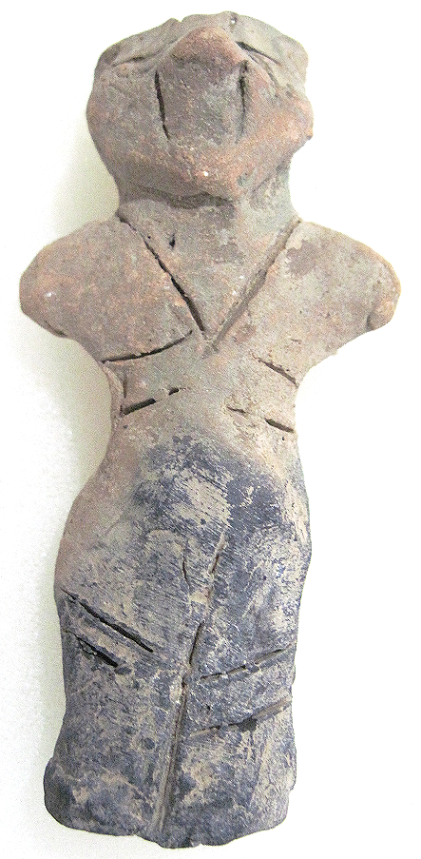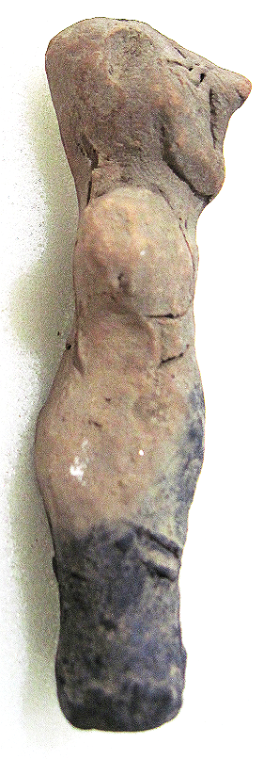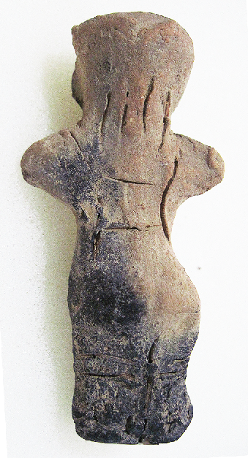

Figs. 1-3. Vinča-Neolithic-Ceramic-Male Anthropomorphic Figurine, 5500-4500 BCE

Case no.: 3

Accession Number: A329

Formal Label: Vinča-Neolithic-Ceramic-Male Anthropomorphic Figurine, 5500-4500 BCE

**Display Description:**

The Vinča culture was named for its type site, Vinča-Belo Brdo tell or mound, on the right bank of the Danube River in Belgrade, Serbia.

Early phase anthropomorphic figurines from this site have triangular heads, flat bodies with short outstretched arms and closed legs. The treatment of facial and body features was done by simple incisions into the clay without modeling. Later phase anthropomorphic figurines are more polygonal, with more pronounced facial features, such as modeled noses and distinctive half-moon eyes and modeled arms. For both periods no indication of a mouth is present. Some theorize that these figurines are deities for ritual practice, while others see them as ancestral cult objects.

This Vinča ceramic male anthropomorphic figurine is from the later period and has a pronounced nose, and eyes, that are set high on the head and are indicated by incisions. It wears hair that extends to the shoulders. Its upper body is bare and suspenders are attached a kulotte that extends below the knees in a cuff. Feet are not indicated.

**LC Classification:** GN776.2.V5

Date or Time Horizon: Middle Neolithic/Copper Age-5500-4500 BCE

Geographical Area: SE Europe

**Map, GPS coordinates:** 44°45′43″N 20°37′23″E (Vinča Belo-Brdo, Serbia)





Fig. 4. Map of the extent of Vinča culture. Adapted after Kaiser and Voytek (1983: 333, fig. 1) and Chapman (1981); from https://www.ucl.ac.uk/silva/rise-metallurgy-eurasia/images/5.1.jpg?hires

Fig. 5. Map of the Central Balkans. Beograd = Belgrade, Serbia, and the approximate location of the Vinča Belo-Brdo site. From http://drakenberg.weebly.com/uploads/6/7/4/7/6747442/9582880.jpg?578

Cultural Affiliation: Vinča Culture

Medium: Clay

Dimensions: H 85.52 mm; 3.37 in

Weight: 17 gm; .5 oz

Condition: original

Provenance: unknown

**Discussion:**

The Vinča culture emerged at the inception of the Middle Neolithic/Copper or Chacolithic Age (5500-4500 BCE) with origins that are debated as either having derived from the earlier Starčevo culture (6200-4500 BCE) of the area, which has been reputed to have been the source of a Proto Indo-European language (PIE), or from migrations from a PIE homeland of a Kurgan or mound-building culture in the Pontic steppe north of the Black Sea (The Kurgan Hypothesis).

Vinča settlers initiated a cultural uniformity that they expressed in farming, making dark pottery fired under reducing conditions comprising zoomorphic and anthropomorphic figurines and making clay tablets with so-called Vinča symbols, which have the appearance of proto-writing (Winn Luca 2008: 26). The type site of the Vinča-Belo Brdo comprised 7 m of Vinča cultural debris overlying 2 m of the previous Starčevo culture. Elsewhere in Serbia and the western part of Romania large Vinča tell villages ranged up to 100 ha in size.



Fig. 6. The extent of the Starčevo culture (6200-4500 BCE) in southeast Europe. After https://upload.wikimedia.org/wikipedia/commons/thumb/e/ea/Starcevo_culture.png/450px-Starcevo_culture.png

Fig. 7. Overview of [Marija Gimbutas](https://commons.wikimedia.org/w/index.php?title=Marija_Gimbutas&action=edit&redlink=1)' [Kurgan](https://commons.wikimedia.org/w/index.php?title=Kurgan&action=edit&redlink=1) hypothesis showing the PIE migrations from the Pontic Steppes into southeastern Europe. Made by [en:User:Dbachmann](https://en.wikipedia.org/wiki/User:Dbachmann) and originally at [en:Image:Kurgan map.png](https://en.wikipedia.org/wiki/Image:Kurgan_map.png).

**References:**

Biagi, P. Gratuze, B. and Boucetta, S. 2007. “New data on the archaeological obsidians from Banat and Transylvania (Romania).” In M. Spataro and P. Biagi (eds.) *A short walk through the Balkans: The first farmers of the Carpathian basin and Adjacent regions*. Quaderno 12. Trieste: Societa per la preistoria e protoistoria della regione Friuli-Venezia Giulia, pp. 129-39.

Chapman, J. 1981. *The Vinča Culture of South East Europe. Studies in chronology, economy and society*. British Archaeological Reports, International Series 117, Oxford: Archeopress. 2v.

Gimbutas, Marija. 1970. “Proto-Indo-European Culture: The Kurgan Culture during the Fifth, Fourth, and Third Millennia B.C.” In Cardona, George; Hoenigswald, Henry M.; Senn, Alfred, Indo-European and Indo-Europeans: Papers Presented at the Third Indo-European Conference at the University of Pennsylvania. Philadelphia: University of Pennsylvania Press, pp. 155–197.

Haak, Wolfgang *et al*. 2015. “Massive migration from the steppe is a source for Indo-European languages in Europe.” bioRxiv preprint first posted online Feb. 10, 2015; doi: http://dx.doi.org/10.1101/013433 Also published in *Nature* doi: [10.1038/nature14317](http://dx.doi.org/10.1038/nature14317)

Holmberg, E.J. 1964. “The Appearance of Neolithic Black Burnished Ware in Mainland Greece,” *American Journal of Archaeology* 68(4): 343-8.

Kaiser, T. and B. Voytek. 1983. “Sedentism and economic change in the Balkan Neolithic,” *Journal of Anthropological Archaeology* 2(4): 323-353.

Luca, S. A. 2008. “The Neolithic and Eneolithic periods in Transylvania.” In Institute of Archaeomythology and Muzeul Brukenthal, *The Danube script: Neo-eneolithic writing in southeastern Europe* [exhibition catalogue]. Sebastopol, California, Institute of Archaeomythology, pp. 23-38.

Özdoğan, M. 2003. “The Prehistory of Northwestern Turkey - The synoptic overview of the latest evidence.” In D.V. Grammenos (ed.) *Recent Research in the Prehistory of the Balkans*. Thessaloniki: Archaeological Institute of Northern Greece and the Archaeological Receipts Fund, pp. 329- 68.

Thissen, L. (2001) “Time trajectories for the Neolithic of Central Anatolia, CANeW project,” http://www.canew.org/files/Thissen%20lecture.pdf, [23.11.2001]: 1-26.

─── (2007) “CANeW Central Anatolia and Cilicia 14C Chart, CANeW project,” http://www.canew.org/cachronobox.html, updated at 16.03.2007.

Vasic, Mīloje M. 1932-1936. *Preistoriska Vinča*. Beograd [Belgrade]: Državne Štamparije. 4 v.

Winn, Milton MacChesney. 1981. [*Pre-writing in Southeastern Europe: the sign system of the Vinča culture ca. 4000 B.C.*](http://www.worldcat.org/title/pre-writing-in-southeastern-europe-the-sgin-system-of-the-vinca-culture-ca-4000-bc/oclc/781534609&referer=brief_results) Calgary, Alberta: Western Publishers.

|  |  |  |
| --- | --- | --- |
|  |  |  |

A325-EUR-Vinca-Neolithic-Ceramic-Anthropomorphic Figurine, 5500-4500 BCE

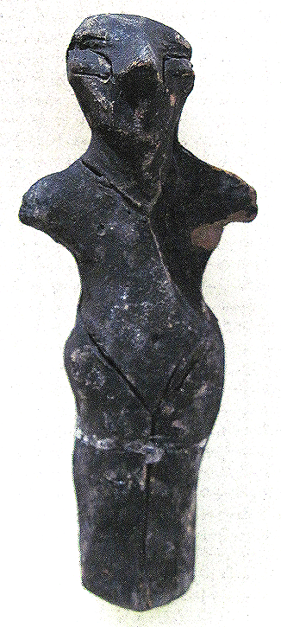 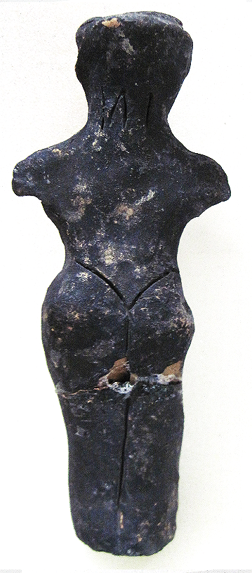 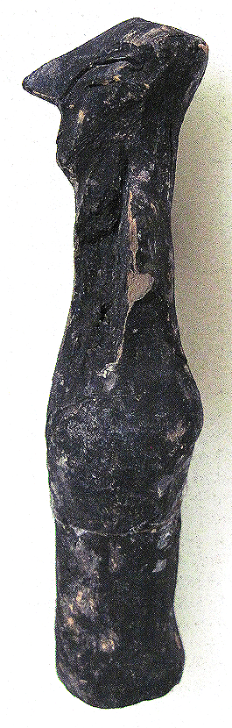

Figs. 1-3. Vinča-Neolithic-Ceramic-Female Anthropomorphic Figurine, 5500-4500 BCE

Case no.: 3

Accession Number: A325

Formal Label: Vinča-Neolithic-Ceramic-Female Anthropomorphic Figurine, 5500-4500 BCE

**Display Description:**

The Vinča culture was named for its type site, Vinča-Belo Brdo tell or mound, on the right bank of the Danube River in Belgrade, Serbia.

Early phase anthropomorphic figurines from this site have triangular heads, flat bodies with short outstretched arms and closed legs. The treatment of facial and body features was done by simple incisions into the clay without modeling. Later phase anthropomorphic figurines are more polygonal, with more pronounced facial features, such as modeled noses and distinctive half-moon eyes and modeled arms. For both periods no indication of a mouth is present. Some theorize that these figurines are deities for ritual practice, while others see them as ancestral cult objects.

This Vinča male anthropomorphic figurine is from the later period, and has a pronounced nose. No mouth is indicated. Its eyes are large, oblong and are set midway on the head and are incised. It wears hair that extends to the nape of its neck. Its upper body is covered by a blouse. Its lower body has trousers that extend to the ground from the waist. Feet are not indicated.

**LC Classification:** GN776.2.V5

Date or Time Horizon: Middle Neolithic/Copper Age-5500-4500 BCE.

Geographical Area: SE Europe

**Map, GPS coordinates:** 44°45′43″N 20°37′23″E (Vinča Belo-Brdo, Serbia)





Fig. 4. Map of the extent of Vinča culture. Adapted after Kaiser and Voytek (1983: 333, fig. 1) and Chapman (1981); from https://www.ucl.ac.uk/silva/rise-metallurgy-eurasia/images/5.1.jpg?hires

Fig. 5. Map of the Central Balkans. Beograd = Belgrade, Serbia, and the approximate location of the Vinča Belo-Brdo site. From http://drakenberg.weebly.com/uploads/6/7/4/7/6747442/9582880.jpg?578

Cultural Affiliation: Vinča Culture

Medium: clay

Dimensions: H 132.69 mm, 5.22 in

Weight: 131 gm, 4.5 oz

Provenance: Anglo-Antiquities, 33 Medlock Grove, Didcot, Oxfordshire, ox11 7xy, United Kingdom

**Discussion:**

The Vinča culture emerged at the inception of the Middle Neolithic/Copper or Chacolithic Age (5500-4500 BCE) with origins that are debated as either having derived from the earlier Starčevo culture (6200-4500 BCE) of the area, which has been reputed to have been the source of a Proto Indo-European language (PIE), or from migrations from a PIE homeland of a Kurgan or mound-building culture in the Pontic steppe north of the Black Sea (The Kurgan Hypothesis).

Vinča settlers initiated a cultural uniformity that they expressed in farming, making dark pottery fired under reducing conditions comprising zoomorphic and anthropomorphic figurines and making clay tablets with so-called Vinča symbols, which have the appearance of proto-writing (Winn Luca 2008: 26). The type site of the Vinča-Belo Brdo comprised 7 m of Vinča cultural debris overlying 2 m of the previous Starčevo culture. Elsewhere in Serbia and the western part of Romania large Vinča tell villages ranged up to 100 ha in size.



Fig. 6. The extent of the Starčevo culture (6200-4500 BCE) in southeast Europe. After https://upload.wikimedia.org/wikipedia/commons/thumb/e/ea/Starcevo_culture.png/450px-Starcevo_culture.png

Fig. 7. Overview of [Marija Gimbutas](https://commons.wikimedia.org/w/index.php?title=Marija_Gimbutas&action=edit&redlink=1)' [Kurgan](https://commons.wikimedia.org/w/index.php?title=Kurgan&action=edit&redlink=1) hypothesis showing the PIE migrations from the Pontic Steppes into southeastern Europe. Made by [en:User:Dbachmann](https://en.wikipedia.org/wiki/User:Dbachmann) and originally at [en:Image:Kurgan map.png](https://en.wikipedia.org/wiki/Image:Kurgan_map.png).

**References:**

Biagi, P. Gratuze, B. and Boucetta, S. 2007. “New data on the archaeological obsidians from Banat and Transylvania (Romania).” In M. Spataro and P. Biagi (eds.) *A short walk through the Balkans: The first farmers of the Carpathian basin and Adjacent regions*. Quaderno 12. Trieste: Societa per la preistoria e protoistoria della regione Friuli-Venezia Giulia, pp. 129-39.

Chapman, J. 1981. *The Vinča Culture of South East Europe. Studies in chronology, economy and society*. British Archaeological Reports, International Series 117, Oxford: Archeopress. 2v.

Gimbutas, Marija. 1970. “Proto-Indo-European Culture: The Kurgan Culture during the Fifth, Fourth, and Third Millennia B.C.” In Cardona, George; Hoenigswald, Henry M.; Senn, Alfred, Indo-European and Indo-Europeans: Papers Presented at the Third Indo-European Conference at the University of Pennsylvania. Philadelphia: University of Pennsylvania Press, pp. 155–197.

Haak, Wolfgang *et al*. 2015. “Massive migration from the steppe is a source for Indo-European languages in Europe.” bioRxiv preprint first posted online Feb. 10, 2015; doi: http://dx.doi.org/10.1101/013433 Now published in *Nature* doi: [10.1038/nature14317](http://dx.doi.org/10.1038/nature14317)

Holmberg, E.J. 1964. “The Appearance of Neolithic Black Burnished Ware in Mainland Greece,” *American Journal of Archaeology* 68(4): 343-8.

Kaiser, T. and B. Voytek. 1983. “Sedentism and economic change in the Balkan Neolithic,” *Journal of Anthropological Archaeology* 2(4): 323-353.

Luca, S. A. 2008. “The Neolithic and Eneolithic periods in Transylvania.” In Institute of Archaeomythology and Muzeul Brukenthal, *The Danube script: Neo-eneolithic writing in southeastern Europe* [exhibition catalogue]. Sebastopol, California, Institute of Archaeomythology, pp. 23-38.

Özdoğan, M. 2003. “The Prehistory of Northwestern Turkey - The synoptic overview of the latest evidence.” In D.V. Grammenos (ed.) *Recent Research in the Prehistory of the Balkans*. Thessaloniki: Archaeological Institute of Northern Greece and the Archaeological Receipts Fund, pp. 329- 68.

Thissen, L. (2001) “Time trajectories for the Neolithic of Central Anatolia, CANeW project,” http://www.canew.org/files/Thissen%20lecture.pdf, [23.11.2001]: 1-26.

─── (2007) “CANeW Central Anatolia and Cilicia 14C Chart, CANeW project,” http://www.canew.org/cachronobox.html, updated at 16.03.2007.

Vasic, Mīloje M. 1932-1936. *Preistoriska Vinča*. Beograd [Belgrade]: Državne Štamparije. 4 v.

Winn, Milton MacChesney. 1981. [*Pre-writing in Southeastern Europe: the sign system of the Vinča culture ca. 4000 B.C.*](http://www.worldcat.org/title/pre-writing-in-southeastern-europe-the-sgin-system-of-the-vinca-culture-ca-4000-bc/oclc/781534609&referer=brief_results) Calgary, Alberta: Western Publishers.

A323-EUR-Vinca-Neolithic-Ceramic-Anthropomorphic Figurine, 5500-4500 BCE

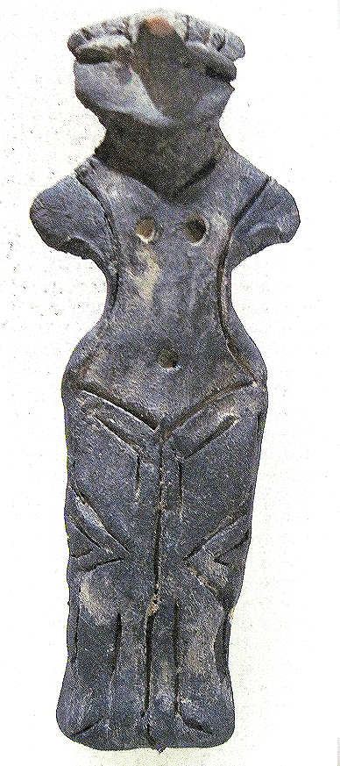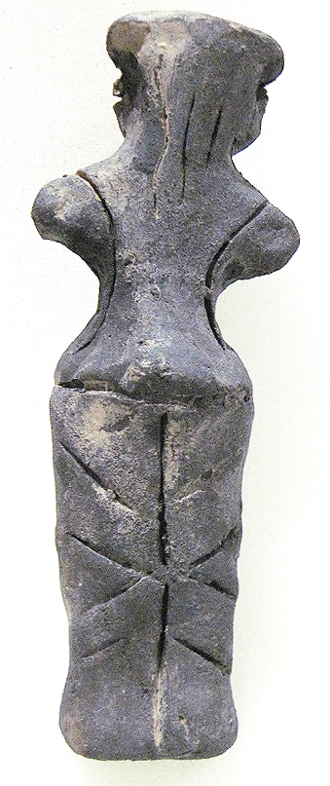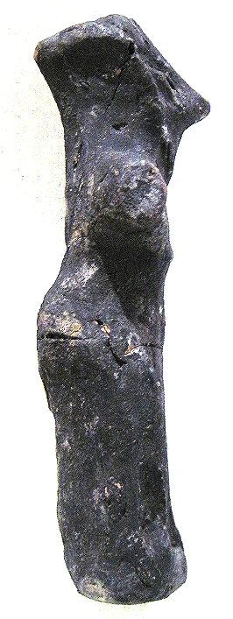

Figs. 1-3. Vinča-Neolithic-Ceramic-Female Anthropomorphic Figurine, 5500-4500 BCE.

Case no.: 3

Accession Number: A323

Formal Label: Vinča-Neolithic-Ceramic-Female Anthropomorphic Figurine, 5500-4500 BCE

**Display Description:**

The Vinča culture was named for its type site, Vinča-Belo Brdo tell or mound, on the right bank of the Danube River in Belgrade, Serbia.

Early phase anthropomorphic figurines from this site have triangular heads, flat bodies with short outstretched arms and closed legs. The treatment of facial and body features was done by simple incisions into the clay without modeling. Later phase anthropomorphic figurines are more polygonal, with more pronounced facial features, such as modeled noses and distinctive half-moon eyes and modeled arms. For both periods no indication of a mouth is present. Some theorize that these figurines are deities for ritual practice, while others see them as ancestral cult objects.

This Vinča ceramic female anthropomorphic figurine is from the later period, and has a pronounced, straight nose, and eyes that are set high on the head, are modeled. Its breasts and navel are marked by punctates and it wears long hair in the back that extends to its shoulders. Its lower body is covered by a flounced kulotte held by suspenders extending to the ground from below the navel. Feet are not indicated.

The midline of the figurine is curved by ca 4o on the right side. This may be an accident of manufacture or it might be displaying a person’s curved spine. If it is the latter this a rare case of documented Neolithic scoliosis.

**LC Classification:** GN776.2.V5

Date or Time Horizon: Middle Neolithic/Copper Age-5500-4500 BCE.

Geographical Area: SE Europe

**Map, GPS coordinates:** 44°45′43″N 20°37′23″E (Vinča Belo-Brdo, Serbia)





Fig. 4. Map of the extent of Vinča culture. Adapted after Kaiser and Voytek (1983: 333, fig. 1) and Chapman (1981); from https://www.ucl.ac.uk/silva/rise-metallurgy-eurasia/images/5.1.jpg?hires

Fig. 5. Map of the Central Balkans. Beograd = Belgrade, Serbia, and the approximate location of the Vinča Belo-Brdo site. From http://drakenberg.weebly.com/uploads/6/7/4/7/6747442/9582880.jpg?578

Cultural Affiliation: Vinča Culture

Medium: clay

Dimensions: H 122.13 mm, 4.81 in

Weight: 258 gm, 9 oz

Provenance: Anglo-Antiquities, 33 Medlock Grove, Didcot, Oxfordshire, ox11 7xy, United Kingdom

**Discussion:**

The Vinča culture emerged at the inception of the Middle Neolithic/Copper or Chacolithic Age (5500-4500 BCE) with origins that are debated as either having derived from the earlier Starčevo culture (6200-4500 BCE) of the area, which has been reputed to have been the source of a Proto Indo-European language (PIE), or from migrations from a PIE homeland of a Kurgan or mound-building culture in the Pontic steppe north of the Black Sea (The Kurgan Hypothesis).

Vinča settlers initiated a cultural uniformity that they expressed in farming, making dark pottery fired under reducing conditions comprising zoomorphic and anthropomorphic figurines and making clay tablets with so-called Vinča symbols, which have the appearance of proto-writing (Winn Luca 2008: 26). The type site of the Vinča-Belo Brdo comprised 7 m of Vinča cultural debris overlying 2 m of the previous Starčevo culture. Elsewhere in Serbia and the western part of Romania large Vinča tell villages ranged up to 100 ha in size.



Fig. 6. The extent of the Starčevo culture (6200-4500 BCE) in southeast Europe. After https://upload.wikimedia.org/wikipedia/commons/thumb/e/ea/Starcevo_culture.png/450px-Starcevo_culture.png

Fig. 7. Overview of [Marija Gimbutas](https://commons.wikimedia.org/w/index.php?title=Marija_Gimbutas&action=edit&redlink=1)' [Kurgan](https://commons.wikimedia.org/w/index.php?title=Kurgan&action=edit&redlink=1) hypothesis showing the PIE migrations from the Pontic Steppes into southeastern Europe. Made by [en:User:Dbachmann](https://en.wikipedia.org/wiki/User:Dbachmann) and originally at [en:Image:Kurgan map.png](https://en.wikipedia.org/wiki/Image:Kurgan_map.png).

**References:**

Biagi, P. Gratuze, B. and Boucetta, S. 2007. “New data on the archaeological obsidians from Banat and Transylvania (Romania).” In M. Spataro and P. Biagi (eds.) *A short walk through the Balkans: The first farmers of the Carpathian basin and Adjacent regions*. Quaderno 12. Trieste: Societa per la preistoria e protoistoria della regione Friuli-Venezia Giulia, pp. 129-39.

Chapman, J. 1981. *The Vinča Culture of South East Europe. Studies in chronology, economy and society*. British Archaeological Reports, International Series 117, Oxford: Archeopress. 2v.

Gimbutas, Marija. 1970. “Proto-Indo-European Culture: The Kurgan Culture during the Fifth, Fourth, and Third Millennia B.C.” In Cardona, George; Hoenigswald, Henry M.; Senn, Alfred, Indo-European and Indo-Europeans: Papers Presented at the Third Indo-European Conference at the University of Pennsylvania. Philadelphia: University of Pennsylvania Press, pp. 155–197.

Haak, Wolfgang *et al*. 2015. “Massive migration from the steppe is a source for Indo-European languages in Europe.” bioRxiv preprint first posted online Feb. 10, 2015; doi: http://dx.doi.org/10.1101/013433 Now published in *Nature* doi: [10.1038/nature14317](http://dx.doi.org/10.1038/nature14317)

Holmberg, E.J. 1964. “The Appearance of Neolithic Black Burnished Ware in Mainland Greece,” *American Journal of Archaeology* 68(4): 343-8.

Kaiser, T. and B. Voytek. 1983. “Sedentism and economic change in the Balkan Neolithic,” *Journal of Anthropological Archaeology* 2(4): 323-353.

Luca, S. A. 2008. “The Neolithic and Eneolithic periods in Transylvania.” In Institute of Archaeomythology and Muzeul Brukenthal, *The Danube script: Neo-eneolithic writing in southeastern Europe* [exhibition catalogue]. Sebastopol, California, Institute of Archaeomythology, pp. 23-38.

Özdoğan, M. 2003. “The Prehistory of Northwestern Turkey - The synoptic overview of the latest evidence.” In D.V. Grammenos (ed.) *Recent Research in the Prehistory of the Balkans*. Thessaloniki: Archaeological Institute of Northern Greece and the Archaeological Receipts Fund, pp. 329- 68.

Thissen, L. (2001) “Time trajectories for the Neolithic of Central Anatolia, CANeW project,” http://www.canew.org/files/Thissen%20lecture.pdf, [23.11.2001]: 1-26.

─── (2007) “CANeW Central Anatolia and Cilicia 14C Chart, CANeW project,” http://www.canew.org/cachronobox.html, updated at 16.03.2007.

Vasic, Mīloje M. 1932-1936. *Preistoriska Vinča*. Beograd [Belgrade]: Državne Štamparije. 4 v.

Winn, Milton MacChesney. 1981. [*Pre-writing in Southeastern Europe: the sign system of the Vinča culture ca. 4000 B.C.*](http://www.worldcat.org/title/pre-writing-in-southeastern-europe-the-sgin-system-of-the-vinca-culture-ca-4000-bc/oclc/781534609&referer=brief_results) Calgary, Alberta: Western Publishers.

A327-Eur-Vinča-Neolithic-Ceramic-Female Anthropomorphic Figurine, 5500-4500 BCE

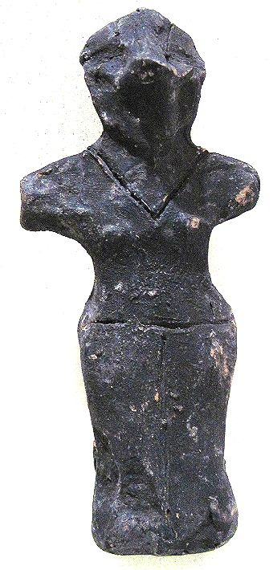 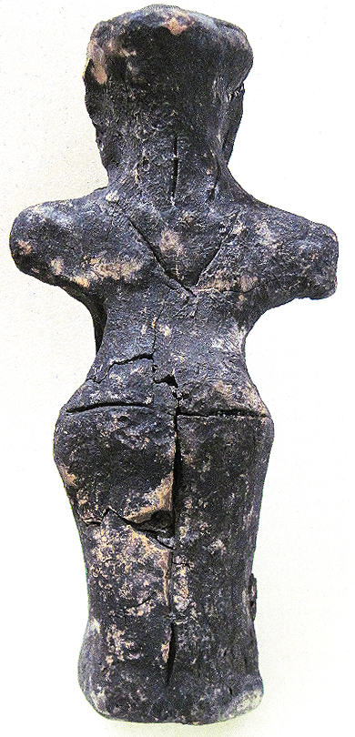 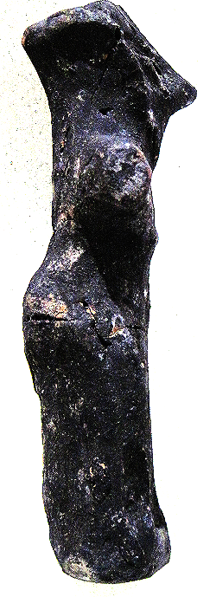

Figs. 1-3. Vinča-Neolithic-Ceramic-Female Anthropomorphic Figurine, 5500-4500 BCE

Case no.: 3

Accession Number: A327

Formal Label: Vinča-Neolithic-Ceramic-Female Anthropomorphic Figurine, 5500-4500 BCE

**Display Description:**

The Vinča culture was named for its type site, Vinča-Belo Brdo tell or mound, on the right bank of the Danube River in Belgrade, Serbia.

Early phase anthropomorphic figurines from this site have triangular heads, flat bodies with short outstretched arms and closed legs. The treatment of facial and body features was done by simple incisions into the clay without modeling. Later phase anthropomorphic figurines are more polygonal, with more pronounced facial features, such as modeled noses and distinctive half-moon eyes and modeled arms. For both periods no indication of a mouth is present. Some theorize that these figurines are deities for ritual practice, while others see them as ancestral cult objects.

This Vinča ceramic female anthropomorphic figurine is from the later period, and has a pronounced nose, and eyes that are set midway on the head, are marked by incisions. Its small breasts are modeled. It wears hair that extends to the nape of its neck. Its upper body is covered by a blouse with sleeves and a design of chevrons. Its lower body continues this design in a straight kulotte extending to the ground from the waist. Feet are not indicated.

**LC Classification:** GN776.2.V5

Date or Time Horizon: Middle Neolithic/Copper Age-5500-4500 BCE.

Geographical Area: SE Europe

**Map, GPS coordinates:** 44°45′43″N 20°37′23″E (Vinča Belo-Brdo, Serbia)





Fig. 4. Map of the extent of Vinča culture. Adapted after Kaiser and Voytek (1983: 333, fig. 1) and Chapman (1981); from https://www.ucl.ac.uk/silva/rise-metallurgy-eurasia/images/5.1.jpg?hires

Fig. 5. Map of the Central Balkans. Beograd = Belgrade, Serbia, and the approximate location of the Vinča Belo-Brdo site. From http://drakenberg.weebly.com/uploads/6/7/4/7/6747442/9582880.jpg?578

Cultural Affiliation: Vinča Culture

Medium: clay

Dimensions: H 127.67 mm, 5.03 in

Weight: 129 gm, 4.5 oz

Provenance: Anglo-Antiquities, 33 Medlock Grove, Didcot, Oxfordshire, ox11 7xy, United Kingdom

**Discussion:**

The Vinča culture emerged at the inception of the Middle Neolithic/Copper or Chacolithic Age (5500-4500 BCE) with origins that are debated as either having derived from the earlier Starčevo culture (6200-4500 BCE) of the area, which has been reputed to have been the source of a Proto Indo-European language (PIE), or from migrations from a PIE homeland of a Kurgan or mound-building culture in the Pontic steppe north of the Black Sea (The Kurgan Hypothesis).

Vinča settlers initiated a cultural uniformity that they expressed in farming, making dark pottery fired under reducing conditions comprising zoomorphic and anthropomorphic figurines and making clay tablets with so-called Vinča symbols, which have the appearance of proto-writing (Winn Luca 2008: 26). The type site of the Vinča-Belo Brdo comprised 7 m of Vinča cultural debris overlying 2 m of the previous Starčevo culture. Elsewhere in Serbia and the western part of Romania large Vinča tell villages ranged up to 100 ha in size.



Fig. 6. The extent of the Starčevo culture (6200-4500 BCE) in southeast Europe. After https://upload.wikimedia.org/wikipedia/commons/thumb/e/ea/Starcevo_culture.png/450px-Starcevo_culture.png

Fig. 7. Overview of [Marija Gimbutas](https://commons.wikimedia.org/w/index.php?title=Marija_Gimbutas&action=edit&redlink=1)' [Kurgan](https://commons.wikimedia.org/w/index.php?title=Kurgan&action=edit&redlink=1) hypothesis showing the PIE migrations from the Pontic Steppes into southeastern Europe. Made by [en:User:Dbachmann](https://en.wikipedia.org/wiki/User:Dbachmann) and originally at [en:Image:Kurgan map.png](https://en.wikipedia.org/wiki/Image:Kurgan_map.png).

**References:**

Biagi, P. Gratuze, B. and Boucetta, S. 2007. “New data on the archaeological obsidians from Banat and Transylvania (Romania).” In M. Spataro and P. Biagi (eds.) *A short walk through the Balkans: The first farmers of the Carpathian basin and Adjacent regions*. Quaderno 12. Trieste: Societa per la preistoria e protoistoria della regione Friuli-Venezia Giulia, pp. 129-39.

Chapman, J. 1981. *The Vinča Culture of South East Europe. Studies in chronology, economy and society*. British Archaeological Reports, International Series 117, Oxford: Archeopress. 2v.

Gimbutas, Marija. 1970. “Proto-Indo-European Culture: The Kurgan Culture during the Fifth, Fourth, and Third Millennia B.C.” In Cardona, George; Hoenigswald, Henry M.; Senn, Alfred, Indo-European and Indo-Europeans: Papers Presented at the Third Indo-European Conference at the University of Pennsylvania. Philadelphia: University of Pennsylvania Press, pp. 155–197.

Haak, Wolfgang *et al*. 2015. “Massive migration from the steppe is a source for Indo-European languages in Europe.” bioRxiv preprint first posted online Feb. 10, 2015; doi: http://dx.doi.org/10.1101/013433 Also published in *Nature* doi: [10.1038/nature14317](http://dx.doi.org/10.1038/nature14317)

Holmberg, E.J. 1964. “The Appearance of Neolithic Black Burnished Ware in Mainland Greece,” *American Journal of Archaeology* 68(4): 343-8.

Kaiser, T. and B. Voytek. 1983. “Sedentism and economic change in the Balkan Neolithic,” *Journal of Anthropological Archaeology* 2(4): 323-353.

Luca, S. A. 2008. “The Neolithic and Eneolithic periods in Transylvania.” In Institute of Archaeomythology and Muzeul Brukenthal, *The Danube script: Neo-eneolithic writing in southeastern Europe* [exhibition catalogue]. Sebastopol, California, Institute of Archaeomythology, pp. 23-38.

Özdoğan, M. 2003. “The Prehistory of Northwestern Turkey - The synoptic overview of the latest evidence.” In D.V. Grammenos (ed.) *Recent Research in the Prehistory of the Balkans*. Thessaloniki: Archaeological Institute of Northern Greece and the Archaeological Receipts Fund, pp. 329- 68.

Thissen, L. (2001) “Time trajectories for the Neolithic of Central Anatolia, CANeW project,” http://www.canew.org/files/Thissen%20lecture.pdf, [23.11.2001]: 1-26.

─── (2007) “CANeW Central Anatolia and Cilicia 14C Chart, CANeW project,” http://www.canew.org/cachronobox.html, updated at 16.03.2007.

Vasic, Mīloje M. 1932-1936. *Preistoriska Vinča*. Beograd [Belgrade]: Državne Štamparije. 4 v.

Winn, Milton MacChesney. 1981. [*Pre-writing in Southeastern Europe: the sign system of the Vinča culture ca. 4000 B.C.*](http://www.worldcat.org/title/pre-writing-in-southeastern-europe-the-sgin-system-of-the-vinca-culture-ca-4000-bc/oclc/781534609&referer=brief_results) Calgary, Alberta: Western Publishers.

A328-EUR-Vinca-Neolithic-Ceramic-Female Anthropomorphic Figurine, 5500-4500 BCE

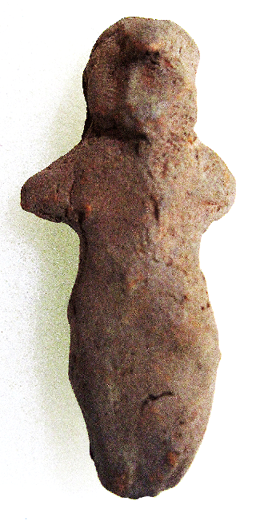 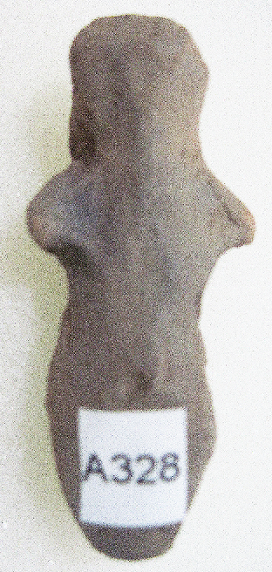 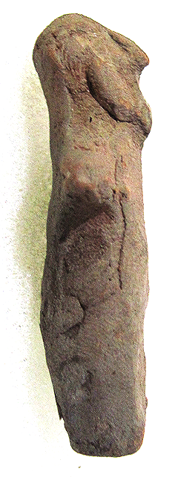

Figs. 1-3. Vinca-Neolithic-Ceramic-Female Anthropomorphic Figurine, 5500-4500 BCE

Formal Label: Vinca-Neolithic-Ceramic-Female Anthropomorphic Figurine, 5500-4500 BCE

Accession Number: A328

Formal Label: Vinča-Neolithic-Ceramic-Female Anthropomorphic Figurine, 5500-4500 BCE

**Display Description:**

The Vinča culture was named for its type site, Vinča-Belo Brdo tell or mound, on the right bank of the Danube River in Belgrade, Serbia.

Early anthropomorphic figurines from this site have triangular heads, flat bodies with short outstretched arms and closed legs. The treatment of facial and body features was done by simple incisions into the clay without modeling. Later anthropomorphic figurines are more polygonal, with more pronounced facial features, such as modeled noses and distinctive half-moon eyes and modeled arms. For both periods no indication of a mouth is present. Some theorize that these figurines are deities for ritual practice, while others see them as ancestral cult objects.

This diminutive Vinca ceramic male anthropomorphic figurine is from the later period. It has an almost aquiline nose, and two heavily modeled, slanting eyes. No hair or clothing is discernible. No feet are discernible.

**LC Classification:** GN776.2.V5

Date or Time Horizon: Middle Neolithic/Copper Age-5500-4500 BCE

Geographical Area: SE Europe

**Map, GPS coordinates:** 44°45′43″N 20°37′23″E (Vinča Belo-Brdo, Serbia)





Fig. 4. Map of the extent of Vinča culture. Adapted after Kaiser and Voytek (1983: 333, fig. 1) and Chapman (1981); from https://www.ucl.ac.uk/silva/rise-metallurgy-eurasia/images/5.1.jpg?hires

Fig. 5. Map of the Central Balkans. Beograd = Belgrade, Serbia, and the approximate location of the Vinča Belo-Brdo site. From http://drakenberg.weebly.com/uploads/6/7/4/7/6747442/9582880.jpg?578

Cultural Affiliation: Vinča Culture

Medium: Clay

Dimensions: H 53.80 mm, 2.117 in

Weight: 12 gm, 3/8 oz

Condition: original

Provenance: Michael Davies, 2 Hanover Court, Didcot, Oxfordshire, ox11 8nu, United Kingdom

**Discussion:**

The Vinča culture emerged at the inception of the Middle Neolithic/Copper or Chacolithic Age (5500-4500 BCE) with origins that are debated as either having derived from the earlier Starčevo culture (6200-4500 BCE) of the area, which has been reputed to have been the source of a Proto Indo-European language (PIE), or from migrations from a PIE homeland of a Kurgan or mound-building culture in the Pontic steppe north of the Black Sea (The Kurgan Hypothesis).

Vinča settlers initiated a cultural uniformity that they expressed in farming, making dark pottery fired under reducing conditions comprising zoomorphic and anthropomorphic figurines and making clay tablets with so-called Vinča symbols, which have the appearance of proto-writing (Winn Luca 2008: 26). The type site of the Vinča-Belo Brdo comprised 7 m of Vinča cultural debris overlying 2 m of the previous Starčevo culture. Elsewhere in Serbia and the western part of Romania large Vinča tell villages ranged up to 100 ha in size.



Fig. 6. The extent of the Starčevo culture (6200-4500 BCE) in southeast Europe. After https://upload.wikimedia.org/wikipedia/commons/thumb/e/ea/Starcevo_culture.png/450px-Starcevo_culture.png

Fig. 7. Overview of [Marija Gimbutas](https://commons.wikimedia.org/w/index.php?title=Marija_Gimbutas&action=edit&redlink=1)' [Kurgan](https://commons.wikimedia.org/w/index.php?title=Kurgan&action=edit&redlink=1) hypothesis showing the PIE migrations from the Pontic Steppes into southeastern Europe. Made by [en:User:Dbachmann](https://en.wikipedia.org/wiki/User:Dbachmann) and originally at [en:Image:Kurgan map.png](https://en.wikipedia.org/wiki/Image:Kurgan_map.png).

**References:**

Biagi, P. Gratuze, B. and Boucetta, S. 2007. “New data on the archaeological obsidians from Banat and Transylvania (Romania).” In M. Spataro and P. Biagi (eds.) *A short walk through the Balkans: The first farmers of the Carpathian basin and Adjacent regions*. Quaderno 12. Trieste: Societa per la preistoria e protoistoria della regione Friuli-Venezia Giulia, pp. 129-39.

Chapman, J. 1981. *The Vinča Culture of South East Europe. Studies in chronology, economy and society*. British Archaeological Reports, International Series 117, Oxford: Archeopress. 2v.

Gimbutas, Marija. 1970. “Proto-Indo-European Culture: The Kurgan Culture during the Fifth, Fourth, and Third Millennia B.C.” In Cardona, George; Hoenigswald, Henry M.; Senn, Alfred, Indo-European and Indo-Europeans: Papers Presented at the Third Indo-European Conference at the University of Pennsylvania. Philadelphia: University of Pennsylvania Press, pp. 155–197.

Haak, Wolfgang *et al*. 2015. “Massive migration from the steppe is a source for Indo-European languages in Europe.” bioRxiv preprint first posted online Feb. 10, 2015; doi: http://dx.doi.org/10.1101/013433 Now published in *Nature* doi: [10.1038/nature14317](http://dx.doi.org/10.1038/nature14317)

Holmberg, E.J. 1964. “The Appearance of Neolithic Black Burnished Ware in Mainland Greece,” *American Journal of Archaeology* 68(4): 343-8.

Kaiser, T. and B. Voytek. 1983. “Sedentism and economic change in the Balkan Neolithic,” *Journal of Anthropological Archaeology* 2(4): 323-353.

Luca, S. A. 2008. “The Neolithic and Eneolithic Periods in Transylvania.” In Institute of Archaeomythology and Muzeul Brukenthal, *The Danube script: Neo-eneolithic writing in southeastern Europe* [exhibition catalogue]. Sebastopol, California, Institute of Archaeomythology, pp. 23-38.

Özdoğan, M. 2003. “The Prehistory of Northwestern Turkey - The synoptic overview of the latest evidence.” In D.V. Grammenos (ed.) *Recent Research in the Prehistory of the Balkans*. Thessaloniki: Archaeological Institute of Northern Greece and the Archaeological Receipts Fund, pp. 329- 68.

Thissen, L. (2001) “Time trajectories for the Neolithic of Central Anatolia, CANeW project,” http://www.canew.org/files/Thissen%20lecture.pdf, [23.11.2001]: 1-26.

─── (2007) “CANeW Central Anatolia and Cilicia 14C Chart, CANeW project,” http://www.canew.org/cachronobox.html, updated at 16.03.2007.

Vasic, Mīloje M. 1932-1936. *Preistoriska Vinča*. Beograd [Belgrade]: Državne Štamparije. 4 v.

Winn, Milton MacChesney. 1981. [*Pre-writing in Southeastern Europe: the sign system of the Vinča culture ca. 4000 B.C.*](http://www.worldcat.org/title/pre-writing-in-southeastern-europe-the-sgin-system-of-the-vinca-culture-ca-4000-bc/oclc/781534609&referer=brief_results) Calgary, Alberta: Western Publishers.